2016 was an unusual year. I returned to the US from Brazil the day after Christmas 2015, with Sonia staying behind to take care of a few things. I flew up to Oregon for the first week of 2016 and it snowed while I was there!

In late January 2016, a couple of days before Sonia was to leave Brazil to join me in California, she had a physical check-up. A lump was found in her breast that was quickly biopsied and found to be malignant. Arrangements were made to remove it the day after I returned to Brazil, in mid-February.

The small tumor was successfully removed and Sonia began 15 radiation treatments in early April. The therapy was completed that month and the healing process went on for several months afterwards. Our extra time down there gave us a chance to spend even more with family and friends in Rio, which was good for the healing.

We took it easy in Rio until Sonia was ready to travel and flew down to Florianópolis for a week in May. As always, we enjoyed our time with Ana and Luiz and their five boys. The *tainha*, a Brazilian gamefish, were running up the coast while we were there, which made for some interesting conversations with some of the local fishermen.

[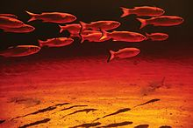](https://pt.wikipedia.org/wiki/Ficheiro:Peixes_na_Lagoa_de_Cara%C3%ADs.jpg)

By July Sonia was well enough for us to follow through with our longstanding plans to visit South Africa. We started practically due east from Rio with ten days in Cape Town. Located at the southern tip of Africa, it was easy for us to take a day trip to the Cape of Good Hope. It is a very beautiful place, teeming with wildlife such as that shown below.

[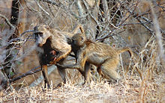](https://en.wikipedia.org/wiki/File:Kr%C3%BCgermonkey2.jpg) [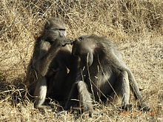](https://en.wikipedia.org/wiki/File:Baboony.jpg)

Chacma baboons are very social. Grooming helps baboons to bond.

[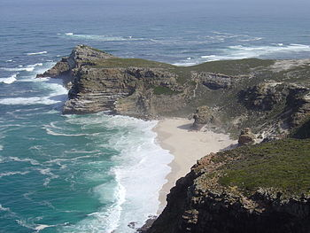](https://en.wikipedia.org/wiki/File:Cape_of_Good_Hope_(Zaian_2008).JPG)

Cape of Good Hope

[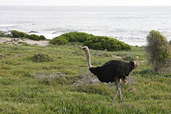](https://en.wikipedia.org/wiki/File:Ostrich_at_Cape_Peninsula.JPG) [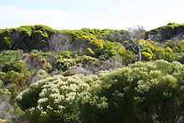](https://en.wikipedia.org/wiki/File:Flora_at_Cape_Peninsula.JPG)

Male Ostrich at Cape Peninsula [Fynbos](https://en.wikipedia.org/wiki/Fynbos) at Cape Peninsula

[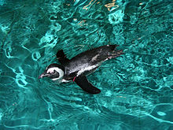](https://en.wikipedia.org/wiki/File:AfricanPenguinNEAq.jpg) [[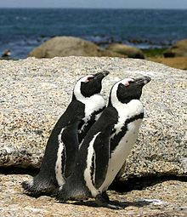](https://en.wikipedia.org/wiki/File:African_penguins_Boulder_Bay_1.jpg)](https://en.wikipedia.org/wiki/File:African_penguins_Boulder_Bay_1.jpg)

African Penguin out of the water

In Cape Town we also visited Robben Island. [Nobel](https://en.wikipedia.org/wiki/Nobel_Prize) Laureate and former [President of South Africa](https://en.wikipedia.org/wiki/President_of_South_Africa) [Nelson Mandela](https://en.wikipedia.org/wiki/Nelson_Mandela) was imprisoned there for 18 of the 27 years he served behind bars before the fall of [apartheid](https://en.wikipedia.org/wiki/Apartheid). Robben Island is with good reason a UNESCO World Heritage Site.

[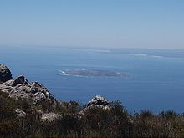](https://en.wikipedia.org/wiki/File:Robben_island_from_table_mountain.jpg) [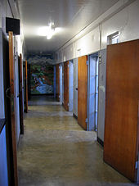](https://en.wikipedia.org/wiki/File:RobbenIslandZellengang.jpg)

Robben Island seen from [Table Mountain](https://en.wikipedia.org/wiki/Table_Mountain) Nelson Mandela’s former cell block

Another very interesting and beautiful place we visited in Cape Town was Table Mountain.

[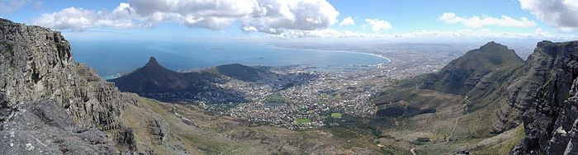](https://en.wikipedia.org/wiki/File:Cape_Town_Pano1.jpg)

Panorama from the top of Table Mountain, from left to right: [Lion's Head](https://en.wikipedia.org/wiki/Lion%27s_Head_(Cape_Town)), [Signal Hill](https://en.wikipedia.org/wiki/Signal_Hill_(Cape_Town)), [Robben Island](https://en.wikipedia.org/wiki/Robben_Island" \o "Robben Island), the [Cape Town](https://en.wikipedia.org/wiki/Cape_Town) city center, [Table Bay](https://en.wikipedia.org/wiki/Table_Bay), and [Devil's Peak](https://en.wikipedia.org/wiki/Devil%27s_Peak_(Cape_Town)).

[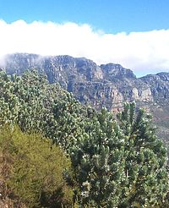](https://en.wikipedia.org/wiki/File:4_Silvertrees_on_Lions_Head_-_Cape_Town.JPG) [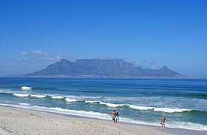](https://en.wikipedia.org/wiki/File:Table_Mountain_DanieVDM.jpg)

The Twelve Apostles Table Mountain

Our next stop was Johannesburg. Jo’burg was very different from beautiful and cosmopolitan Cape Town. It was a huge, dusty, industrial hub, not only of South African, but all of Africa. However, it did have a few world class museums, the first of which was the Apartheid Museum. This world class museum tells in chilling detail the complete story of apartheid. When entering the museum, you are separated from your companion and classified as either “colored” or “white” in front of a life size photo of a scary looking classification board. This is effective in giving you some feeling of what the experience must have been like. You might have had very light skin, but all it took to be classified as “colored” was discovery by government investigators of an African or East Indian member in the generations of your family history. You could then be picked up in a government sweep and if you’d left home without your government issued passbook, imprisoned immediately for years without legal recourse. You could also have had the neighborhood of Cape Town in which you lived condemned for demolition so that whites could live there and have been relocated to a “township” hours by bus from the city, where the jobs were. This is the kind of history that is most satisfactory to study, as it is history that eventually worked out the way it should have.

[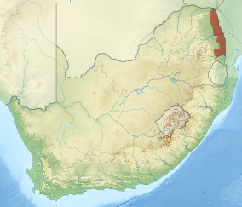](https://en.wikipedia.org/wiki/File:Kruger_National_Park_locator_map.svg)

Location of Kruger National Park in South Africa

Our final stop on this trip was Kruger Park, where we spent a week on a walking safari with two old friends of ours from Colorado and two bush guides who led us along trails for eight hours a day. We had a long drive up there from Jo’burg across the Transvaal to the Zimbabwean border.

We were lucky to spent our time among members of the Makuleke Tribe, a Tsong speaking people aliving in the Pafuri Triangle of South Africa at the confluence of the Luvuvhu and Limpopo rivers in what is now the Kruger National Park.This agricultural and fishing tribe settled the area in the early nineteenth century. After the park was created, the Makuleke were exiled outside the gates, but had title to their lands restored as part of post-apartheid restitution laws. There are about 12,000 members of the clan and they are part of a successful eco-tourism economic development.

|  |
| --- |
|  |
|  |

[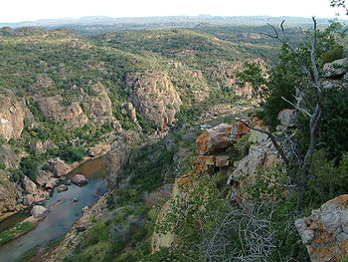](https://en.wikipedia.org/wiki/File:Makuleke4.JPG)

A westward view of Lanner Gorge near the confluence of the Limpopo and Luvuvhu rivers

|  |  |
| --- | --- |
|  |  |
|  |  |
|  |  |
|  |  |

[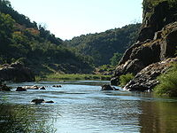](https://en.wikipedia.org/wiki/File:Makuleke2.JPG)

The walls of Lanner Gorge in the Makuleke are made of ancient sandstones. The Luvuvhu River has carved a deep canyon into these rocks.

From about 1.5 million years ago, human ancestors, who were probably members of the species Homo erectus, were attracted to the area as a source of raw material for making early stone age tools.   Beautifully crafted hand axes are evidence that this early stone tool culture and lasted from around 1.7 million years ago until around 250,000 years ago.

Tools of the Middle Stone Age are also in abundance in the area, particularly on top of hills and mountains in the region where these humans were apparently using overlooks and high spots to scout for game. On top of many hills can be found quite literally thousands of Middle Stone age knives, scrapers and [spear](https://en.wikipedia.org/wiki/Spear)-points. The Middle Stone Age begins around 250,000 years ago and ends around 25 – 35 thousand years ago.

The Middle Stone age is followed in this region by the Latest Stone Age and most places have evidence of the micro-lithic cultures that characterize this hunter-gather lifestyle of modern humans. The Latest Stone Age merges with the culture of Iron-aged Bantu speaking pastoralists who moved into the region around 1,500 to 2,000 years ago.  Rock art from this period is abundant in the region, particularly South of the Luvuvhu, but good examples have recently been discovered in the Pafuri region itself.

From around 1,200 a large cultural civilization and trade network began to emerge just to the North as is evidenced at such sites as Mapungubwe. Also, the idea of sacred leadership emerged.  Sacred leaders were elite members of the community, types of prophets, people who were thought to have supernatural powers and the ability to predict the future. These early civilizations represented the rise of one of the greatest ancient trade networks ever seen.

[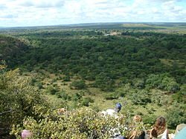](https://en.wikipedia.org/wiki/File:Makuleke1.JPG)

Looking out over the floodplains of the Luvuvhu River and the Limpopo River in the far distance

Through interactions and trade with Muslim traders plying the Indian ocean as far south as present day Mozambique – the region emerged as a trade center producing gold and ivory and trading for glass beads and porcelain from as far away as China.

The end of Mapungubwe occurred at the same time as the rise of an even greater trading and architectural civilization – that of Great Zimbabwe – which flourished for more than one hundred years. The centre of power then shifted to the south at a site known as Khami near present-day Bulawayo. It was then, around 1550, that groups crossed the Limpopo and founded numerous flourishing settlements in the Pafuri region including that of Thulamela on the southern bank of the Luvuvhu.Thulamela was one of many walled cities that existed in the Pafuri triangle – almost every hill and overlook in the area has evidence of significant occupation during this period.[[5]](https://en.wikipedia.org/wiki/Makuleke#cite_note-Berger-5) Thulamela and the other walled cities of the region were occupied at about the same time Portuguese trade began on the eastern coast of southern Africa.  The wealth and sophistication of these people is evident by the beautifully crafted gold jewelry, Arab glass beads and Chinese porcelain found in the sites and accompanying burials of sacred leaders.The Thulamela culture ended around 1650.

The Makuleke area was forcibly taken from the Makuleke people by the Apartheid South Africa government in 1969 and about 1500 of them were relocated to land to the south so that their original tribal areas could be integrated into the greater Kruger National Park. In 1996 the Makuleke tribe submitted a land claim for 19,842 hectares (198.42 km2) in the northern park of the Kruger National Park. The land was given back to the Makuleke people, however, they chose not to resettle on the land but to engage with the private sector to invest in tourism, thus resulting in the building of several game lodges

Due to its proximity to Zimbabwe and Mozambique, the area had been heavily poached by the time the Makuleke people received the land back. Recent anti-poaching efforts and re-introduction of game including white rhino, have resulted in significant increases in the number of animals.

The introduction of significant species which have been absent for many years (more than 120 years in the case of the white rhino), the protection of all animal and plant life, and partnering with the Makuleke people in sustainable ecotourism mark the beginning of the restoration of ecological integrity to the area.

[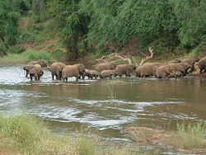](https://en.wikipedia.org/wiki/File:Makuleke6.JPG)

A breeding herd of elephants crossing the Luvuvhu in the Makuleke area

The Pafuri region is famous for its bird watching and more than 250 bird species have been recorded in a year. While comprising only about 1% of the Kruger National Park's actual area, the area contains plants and animals representing almost 75% of the Parks total diversity.

The area has both semi-arid vegetation including numerous large baobabs as well as rich riverine forests with large Nyala trees. While game is plentiful, one is most likely to encounter Nyala, buffalo and Bushbuck in the riverine areas and drier adapted game, including white rhino, in the uplands. The area is famous for its elephant herds in winter, which come to drink from the Luvuvhu river.

Many people visiting the modern Limpopo expecting the “great grey-green greasy Limpopo” of Kipling fame and yet seeing a great sand filled body instead. This is, however, a recent phenomenon, probably due to a great extent to the over utilization by agriculture of the water resources of the river. As recently as 1950, a Zambezi shark was caught at the confluence of the Luvuvhu and Limpopo river. This desertification is a significant problem which must be addressed in order to conserve African game in this important region.

[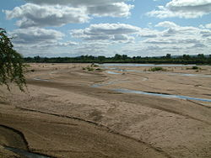](https://en.wikipedia.org/wiki/File:Makuleke5.JPG)

The dry Limpopo in the Winter near the boundary

The Pafuri region is famous for its bird watching and more than 250 bird species have been recorded in a year. While comprising only about 1% of the Kruger National Park's actual area, the area contains plants and animals representing almost 75% of the Parks total diversity.

The area has both semi-arid vegetation including numerous large baobabs as well as rich riverine forests with large Nyala trees. While game is plentiful, one is most likely to encounter Nyala, buffalo and Bushbuck in the riverine areas and drier adapted game, including white rhino, in the uplands. The area is famous for its elephant herds in winter, which come to drink from the Luvuvhu river.

The number of animals we saw was astounding. Of course all of these species as listed as vulnerable to extinction as a result of poaching or habitat loss, especially the *White* Rhino, African Elephant, Lion, Leopard, Hippo and Giraffe, but the national parks and game reserves of east and south Africa at least offer some protection for them. The *Black* Rhino, which we did not see, is listed as critically endangered.

The first day we went out on the trail, we met up with a small herd of African Buffalo. They are one of the most dangerous animals in Africa as a result of their unpredictable nature. We were perhaps only 20 yards from the herd when we spotted them. Three bulls looking directly at us made me very nervous. There was a big tree lying on the ground around 10 yards away and I was pondering whether we could reach it before the bulls reached us. Like many wild animals, the African Buffalo’s senses of smell and hearing are better

[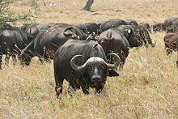](https://en.wikipedia.org/wiki/File:Afrikanische_B%C3%BCffel_(Syncerus_caffer)_1.jpg) [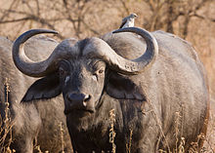](https://en.wikipedia.org/wiki/File:Serengeti_Bueffel1.jpg)

African Buffalo herd An inquisitive bull

developed than their sight, so we were being very quiet. After about ten minutes of staring in our direction, they turned tail and retreated at speed. This was typical of all the wildlife we saw, with the exception of the elephant, our species of the year (see below).

The most numerous of them were the Impala and the Zebra. The Impala is a medium-sized Antelope and the Zebra is an African member of the Horse family. Both species are very fast and the Impalas sometimes leap very gracefully while running. This was a very beautiful sight to see!

[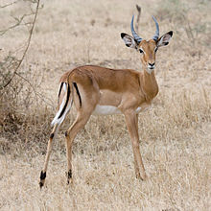](https://en.wikipedia.org/wiki/File:Serengeti_Impala3.jpg) [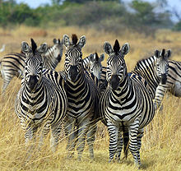](https://en.wikipedia.org/wiki/File:Zebra_Botswana_edit02.jpg)

Impala bull Zebra herd

Other plentiful species we saw a lot of included the Greater Kudu and Wart Hog shown below.

[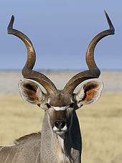](https://en.wikipedia.org/wiki/File:Tragelaphus_strepsiceros_%E2%99%82_(head).jpg) [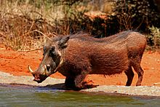](https://en.wikipedia.org/wiki/File:Common_warthog_(Phacochoerus_africanus)_male.jpg)

Kudus were among the species that entered our encampment at night and we could hear them just outside our tents. At the end, when we were in an outlying area of the lodge about fifteen feet above the floodplain of the Luvuvhu River, we could hear lions and leopards below us. We sat near a leopard up close our last day!

[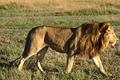](https://en.wikipedia.org/wiki/File:African_Lion_3.jpg) [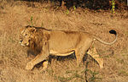](https://en.wikipedia.org/wiki/File:Asiatic_lion_03.jpg) [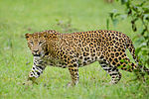](https://en.wikipedia.org/wiki/File:Nagarhole_Kabini_Karnataka_India,_Leopard_September_2013.jpg)

[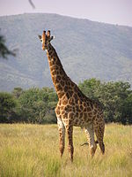](https://en.wikipedia.org/wiki/File:Giraffe_standing.jpg)

Giraffes, the tallest living terrestrial animal, are found in small numbers in the farthest northern part of Kruger Park, where we were located. They were the only large mammal we were unable to see or see sign of.

We had fascinating encounters with a pod of Hippopotamus and a White Rhinoceros family on succeeding afternoons near the end of our safari. These were thrilling, each in its own way. We spotted the Hippopotamus pod of perhaps 20 animals in the Luvuvhu River. The two biggest bulls were the most interested in us and approached most closely. Luckily we were positioned on the river bluff above them and Hippos don’t swim nearly as fast as they run, for they are aggressive, dangerous animals! The most amazing thing about them is the loud, very deep bellow they produce from their enormous bodies. The Rhinos, for their part, were further away and can hardly see at all. We were also downwind of them. In the late afternoon twilight, they appeared to be almost surreal, like totemic “spirit” animals seen in a tribal member’s vision.

[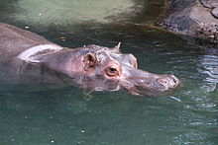](https://en.wikipedia.org/wiki/File:Disney-Animal-Kingdom-Hippo-7940.jpg) [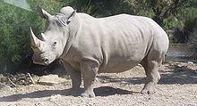](https://en.wikipedia.org/wiki/File:Rhinoc%C3%A9ros_blanc_JHE.jpg)

African elephant – Species of the Year



The photo above was taken by Rhodes Bezuidenhout of Shangani Trails, our chief guide. While we were with him, Rhodes imparted to us much of his vast storehouse of knowledge about the animals of southern Africa in general and elephants in particular. We saw elephants everywhere while we were there, usually munching on the vegetation, even around the edges of our camp!

|  |
| --- |
| The following information edited from Wikipedia, to whom the author is extremely grateful and continues to support. |

|  |  |  |  |
| --- | --- | --- | --- |
| [African Bush Elephant.jpg](https://en.wikipedia.org/wiki/File:African_Bush_Elephant.jpg) | | | |
|  | |  | |
|  | | |
|  |  | |

The African bush elephant is the largest living terrestrial animal. Their thickset bodies rest on stocky legs and their enormous ears enable substantial heat loss. The upper lip and nose form a trunk, which acts as a fifth limb, a sound amplifier, and an important method of touch. African elephants' trunks end in two opposing lips, whereas the Asian elephant trunk ends in a single lip. In *L. africana*, males stand up to 4.0 m (13 ft) tall at the shoulder and weigh as much as 6,000 kg (13,330 lb), while females stand up t o 2.6 m (9 ft) tall and weigh up to 3,222 kg (7,125 lb).

Elephants have four molars; each weighs about 5 kg (11 lb) and measures about 30 cm (12 in) long. As the front pair wears down and drops out in pieces, the back pair moves forward, and two new molars emerge in the back of the mouth. Elephants replace their teeth four to six times in their lifetime. At about 40 to 60 years of age, the elephant loses the last of its molars and will likely die of starvation, a common cause of death. African elephants have 24 teeth in total, six on each quadrant of the jaw.

The elephants' tusks are firm teeth; the second set of incisors become the tusks. They are used to dig for roots and strip the bark from trees for food; to fight each other during mating season; and to defending themselves against predators. The tusks weigh up to 45 kg (99 lb) and can be up to 2.4 m (5–8 ft) long. Unlike Asian elephants, both male and female African elephants have tusks. They are curved forward and continue to grow throughout the elephant's lifetime. Elephants don’t drink with their trunks, but use them as “tools” to drink with. This is accomplished by filling the trunk with water and then using it as a hose to pour it into the elephant’s mouth.  Elephants can swim and use their trunk to breathe like a snorkel in deep water.

One of the principal habitats of the African bush elephant is mopane woodlands (see habitat of the year, below).

[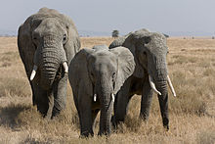](https://en.wikipedia.org/wiki/File:Serengeti_Elefantenherde2.jpg)

Female bush elephants, which usually live in herds

African elephant societies are arranged around family units, which are made up of around ten closely related females and their calves. They are led by an older female known as the *matriarch*. When separate family units bond, they form *kinship* or *bond* groups. After puberty, male elephants tend to form alliances with other males.

Elephants are at their most fertile between the ages of 25 and 45. Calves are born after a gestation period of nearly two years. The calves are cared for by their mother and other young females in the group, known as *allomothers*.

Elephants use some vocalizations that are beyond the hearing range of humans, to communicate across large distances. Elephant mating rituals include the gentle entwining of trunks (see photos below).

While feeding, elephants use their trunks to pluck at leaves and their tusks to tear at branches, which can cause enormous damage to foliage. A herd may deplete an area of foliage depriving other herbivores for a time. African elephants may eat up to 450 kilograms (992 lb) of vegetation per day! And they drink up to 80 gallons of water a day!

African elephants are highly intelligent, and they have a very large and highly convoluted neocortex, a trait they share with humans, apes and some dolphin species. They are amongst the world's most intelligent species. With a mass of just over 5 kg (11 lb), elephant brains are larger than those of any other land animal and although the largest whales have body masses twenty-fold those of a typical elephant, whale brains are barely twice the mass of an elephant's brain. The elephant's brain is similar to that of humans in terms of structure and complexity. For example, the elephant's cortex has as many neurons as that of a human brain suggesting convergent evolution.[[27]](https://en.wikipedia.org/wiki/African_elephant#cite_note-27)

Elephants exhibit a wide variety of behaviors, including those associated with grief, learning, allomothering, mimicry, art, play, a sense of humor, altruism, use of tools, compassion, cooperation, self-awareness, memory and possibly language.  All point to a highly intelligent species that is thought to be equal with cetaceans and primates.

[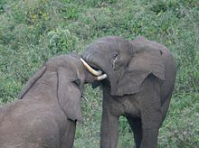](https://en.wikipedia.org/wiki/File:Bull_elephants_small.jpg)

Bull elephants in mock aggression

African elephants show sexual dimorphism in weight and shoulder height by age 20, due to the rapid early growth of males; by age 25, males are double the weight of females. However, both sexes continue to grow throughout their lives.

Female African elephants are able to start reproducing at around 10 to 12 years of age,and are in estrus for about 2 to 7 days. They do not mate at a specific time; however, they are less likely to reproduce in times of drought than when water is plentiful. The gestation period of an elephant is 22 months and fertile females usually give birth every 3 – 6 years, so if they live to around 50 years of age, they may produce 7 offspring. Females are a scarce and mobile resource for the males so there is intense competition to gain access to estrous females.

Post sexual maturity, males begin to experience *musth*, a physical and behavioral condition that is characterized by elevated testosterone, aggression and more sexual activity. *Musth* also serves a purpose of calling attention to the females that they are of good quality, and it cannot be mimicked as certain calls or noises may be. Males sire few offspring in periods when they are not in *musth*. During the middle of estrus, female elephants look for males in *musth* to guard them. The females will yell, in a loud, low way to attract males from far away. Male elephants can also smell the hormones of a female ready for breeding. This leads males to compete with each other to mate, which results in the females mating with older, healthier males. Females choose to a point who they mate with, since they are the ones who try to get males to compete to guard them. However, females are not guarded in the early and late stages of estrus, which may permit mating by younger males not in musth.

Males over the age of 25 compete strongly for females in estrous, and are more successful the larger and more aggressive they are. Bigger males tend to sire bigger offspring. Wild males begin breeding in their thirties when they are at a size and weight that is competitive with other adult males. Male reproductive success is maximal in mid-adulthood and then begins to decline. However, this can depend on the ranking of the male within their group, as higher-ranking males maintain a higher rate of reproduction. Most observed matings are by males in *musth* over 35 years of age. Twenty-two long observations showed age and *musth* are extremely important factors as older males have been observed to have markedly elevated paternity success compared with younger males, suggesting the possibility of sexual selection for longevity in this species.

Males usually stay with a female and her herd for only a few weeks before moving on in search for another mate. Less than a third of the population of female elephants will be in estrus at any given time and gestation period of an elephant is long, so it makes more evolutionary sense for a male to search for as many females as possible rather than stay with one group. Some elephant fetuses will morph together in the womb and create abnormalities with the ears.

[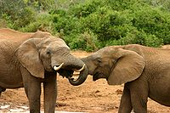](https://en.wikipedia.org/wiki/File:Elephant_mating_ritual.jpg) [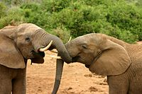](https://en.wikipedia.org/wiki/File:Elephants_mating_ritual_2.jpg)

  Elephant mating ritual

[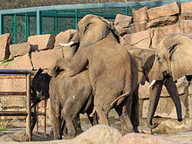](https://en.wikipedia.org/wiki/File:Berlin_Tierpark_Friedrichsfelde_12-2015_img13_African_elephant.jpg)

Elephants mating in captivity

The social behavior of elephants in captivity mimics that of those in the wild. Females are kept with other females, in groups, while males tend to be separated from their mothers at a young age, and are kept apart. Males and females are allowed to interact for specific purposes such as breeding. Females are more often kept in captivity because they are easier and less expensive to house.

[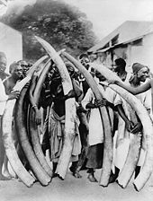](https://en.wikipedia.org/wiki/File:Ivory_trade.jpg)

Tribesmen with elephant tusks, Dar es Salaam, c.  1900

During the 20th century, poaching significantly reduced the African elephant population. According to the World Wide Fund, there were between 3 and 5 million African elephants as recently as the 1930s and 1940s. Between 1980 and 1990 the population of African elephants was more than halved, from 1.3 million to around 600,000. Between 1973 and 1989, the African elephant population of Kenya declined by 85%. In Chad, the population declined from 400,000 in 1970 to about 10,000 in 2006. The population in the Tanzanian Selous Game Reserve, once the largest of any reserve in the world, dropped from 109,000 in 1976 to 13,000 in 2013. In Tanzania between 2009 and 2014, 85,000 elephants were lost to poaching.

In 1989, CITES (Convention on International Trade in Endangered Species of Wild Fauna and Flora) banned international trade in ivory to fight this massive illegal trade. After the ban came into force, major ivory markets were eliminated. As a result, African elephant populations experienced a decline in illegal killing, particularly where they were protected. This allowed some elephant populations to recover. Nevertheless, within countries where wildlife management authorities are greatly under-funded, poaching is still a serious problem.

The two threats to the African elephant are demand for ivory and changes in land usage/habitat destruction. The majority of the ivory leaving Africa continues to be acquired and transported illegally. From 2006 to 2012 the magnitude of poaching increased.

According to the World Wildlife Fund, in 2014 the total population of African elephants was estimated to be around 700,000, and the Asian elephant population was estimated to be around 32,000. The population of African elephants in Southern Africa is large and expanding, with more than 300,000 within the region; Botswana has 200,000 and Zimbabwe 80,000. Large populations of elephants are confined to well-protected areas. However, conservative estimates were that less than 20% of the African elephant range was under formal protection.

Protection of African elephants is a high-profile conservation cause in many countries. In 1989, the Kenyan Wildlife Service burned a stockpile of tusks in protest against the ivory trade. However, African elephant populations can be devastated by poaching despite nominal governmental protection, and some nations permit the hunting of elephants for sport. In 2012, *The New York Times* reported a large upsurge in ivory poaching, with about 70% of the product flowing to China.

Conflicts between elephants and a growing human population are a major issue in elephant conservation. Human encroachment into natural areas where bush elephants occur has spurred research into methods of safely driving groups of elephants away from humans. For example playback of the recorded sounds of angry honey bees has been found to be remarkably effective at prompting elephants to flee an area. The International Union for Conservation of Nature (“IUCN”) African elephant specialist group has set up a *human-elephant conflict* working group. They believe that different approaches are needed in different countries and regions, and so develop conservation strategies at national and regional levels.

China was the biggest market for poached ivory but announced they would phase out the legal domestic manufacture and sale of ivory products in May, 2015, and in September 2015 China and the U.S.A. said they would enact a nearly complete ban on the import and export of ivory.

Two months ago, IUCN estimated that Africa's elephant population is 415,000. They report that in the past decade, this is a decline of 111,000 elephants, or more than 25%. This is reported as the worst decline in the past 25 years.

By far, our closest and most interesting wildlife interactions in Africa were with elephants. Early on, a big bull approached us while we were on foot and came within 10 meters (30 feet) of us while we were crouching silently beneath his immense body. He stood there staring at us for so long—perhaps 15 minute—that our guide Rhodes, who was closest to him, began talking to him slowly and reassuringly that we meant him no harm. This “elephant whispering” was quite effective and he went on his way soon afterward.

The next day we had the great good fortune to come upon a breeding herd of around a hundred mostly female and juvenile elephants. We crouched unbeknownst to them upwind on an elevated opposite river bank and gazed wonderingly at them bathing and wallowing in the mud to cake and sooth their dry, insect-bitten and sun-burnt skin. And of course they were also tanking up on huge quantities of water. It was easy to see that this was one of life’s greatest pleasures for them. What an incredible experience!

We had many close encounters with elephants, especially when we were in the jeep driving to or from our trailheads. Often they would block the jeep road while they were feeding, which they do most of their waking hours in order to keep their enormous bodies energized. Elephants are very intelligent and curious animals, and sometimes they would approach our jeep to have a closer look at us. This was not always a comfortable experience for us, as they towered over our jeep and could easily have crushed us with their hug trunk, or leg, or rear end! I was usually riding “shotgun” (on the left side in South Africa) and once had an “ellie” come so close I could have touched him! What made this more trying then some of our other encounters was that, on top of his close proximity to me, he had torn a whole in mid-section of his trunk, was clearly in *musth* (see above), and was showing obvious signs of irritation that we had disturbed his solitude. This occasioned further “elephant whispering” by our assistant guide Biff, who happened to be driving at the time. She proved to be Rhodes’s equal, or perhaps superior, in this arcane practice as she soothed the savage beast, who appeared satisfied to have delivered his protest, and sent him on his way. Sonia was even more relieved than I was and resumed sitting position on the seat behind me.

Mopane Woodlands – Habitat of the Year

[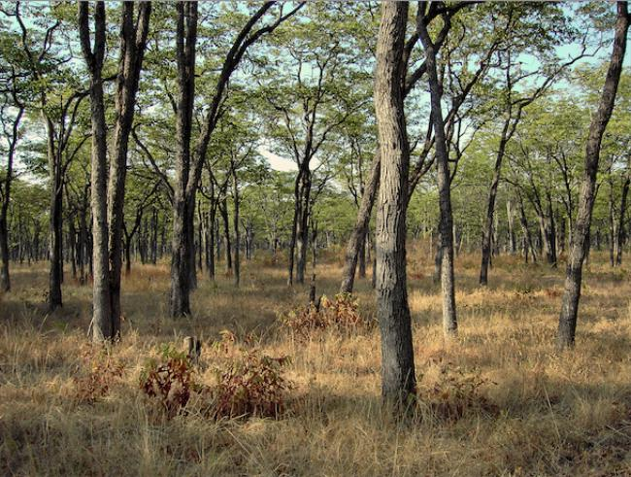](https://experiment-uploads.s3.amazonaws.com/updates/1177/Screen_Shot_2014-03-23_at_10.46.00_PM.png)

Mopane Woodlands are dispersed throughout southern Africa. They support some of the largest and most significant wildlife populations in Africa, particularly those of the endangered bush elephant and critically endangered black rhino. Important populations of predators such as lions and leopards are also found in the Mopane Woodlands. The abundance of wildlife can be largely attributed to the high level of protection in the ecoregion, in which more than 45 percent of the habitat is devoted to various forms of state and private conservation. Two recently activated cross-border conservation efforts are further increasing the extent of protected lands in South Africa, Mozambique, and Zimbabwe.

The size of this Afrotropical ecoregion is 182,700 square miles and the WWF (to which the author is indebted for much of the following information) gives its conservation status as “Relatively Stable/Intact”.

Mopane Woodlands are widespread throughout the lower-lying areas in the eastern half of southern Africa. This ecoregion is characterized by the dominance of the tree Colophospermum mopane, which is the sole canopy species throughout much of its range. Elevation and rainfall are the major environmental factors separating Mopane Woodlands from its major neighboring ecoregions. The ecoregion falls largely within the tropical summer-rainfall zone. Terrain is generally flat or gently undulating along the floors of the major river valleys.

[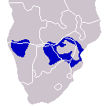](https://en.wikipedia.org/wiki/File:Mopane-Distribution-small.png) [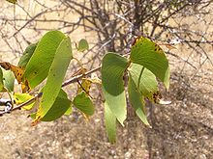](https://en.wikipedia.org/wiki/File:Mopane.JPG)

Distribution of Mopane trees Butterfly-shaped leaves of the Mopane

As many as 2,000 vascular plant species have been recorded from South Africa’s Kruger National Park (19,624 km2) in the southeastern portion of the ecoregion. Mopane trees are ecologically important as browse for numerous animals, notably elephants, and economically the wood is prized for building and fuel.

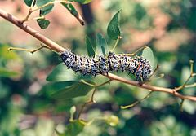 [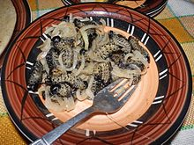](https://en.wikipedia.org/wiki/File:Mopane-Raupen_gekocht.JPG)

Mopane worm (or caterpillar) on a mopane branch Cooked mopane worms with onions

Also, the tree is the major host for the seasonally abundant mopane worm, which is an important human food and economic resource. The harvesting and sale of mopane worms is a multi-million rand industry in southern Africa. (The South African currency is in rand, currently at about 14 to the US Dollar.)

This ecoregion is one of the most important areas for vertebrate diversity in southern Africa, particularly for mammals. The biota and associated natural processes remain largely intact as a result of the extensive and well-maintained system of national parks and reserves in the ecoregion. Vegetation here is more nutritive than surrounding ecoregions with higher rainfall, and as a result, the area is well known for supporting large concentrations of ungulates, including Giraffe, Impala, Kudu, and Nyala. The ecoregion also supports some of the most significant remaining populations of the critically endangered Black rhino, the endangered African Elephant, as well as White rhino, Hippopotamus, African buffalo, and Blue wildebeest,

Although large blocks of this habitat remain, in many areas natural migration routes have been restricted by manmade obstacles, such as the western boundary fence of Kruger National Park and the cattle and veterinary fences in northeastern Botswana. These restrictions on migration have particularly affected the blue wildebeest.

Predators are also abundant, and the full assemblage of lion, cheetah, spotted hyena, and leopard is found in a number of the ecoregion’s large protected areas, mostly notably Kruger National Park and its adjoining private reserves. The endangered wild dog is found in significant numbers within the protected areas of the ecoregion.

Elephant browsing activity and fire are the two major natural factors shaping the vegetation and associated fauna within the Mopane Woodlands. Elephants crop the larger trees in savannas and woodlands, creating openings exploited by grasses, thus increasing fire frequency and intensity.

The Greater Zambezian and Mopane Woodlands enjoy a healthy conservation status. The poor agricultural potential of the region means that the majority of habitats are still relatively intact. Some land transformation has occurred, especially in the extreme south of the ecoregion, where dense human populations border Kruger National Park in South Africa. In these areas, as much as 43 percent of the land has been changed by agriculture and settlement, while livestock grazing and resource-use activities heavily impact the bulk of the remaining natural habitat. Aside from the southeastern portion of the ecoregion in South Africa and Swaziland, the majority of Zambezian and Mopane Woodlands occur in areas of low human population density.

The agricultural marginality of the Zambezian and Mopane Woodlands and the large attendant mammal populations have encouraged the establishment of an extensive protected area network in the ecoregion. Government conservation areas protect over 40 percent of the ecoregion with private game ranches, nature reserves and conservancies in South Africa, Zimbabwe, and Botswana adding a further 5 to 10 percent to the total area conserved. The most significant national parks are Kruger in South Africa, Gonarezhou in Zimbabwe, and Banhine, Gorongosa, and Zinave National Parks in Mozambique. These parks cover much of the large southeastern portion of the ecoregion.

The most widespread threat to the ecoregion is poaching and exploitation of wildlife. Black rhino and wild dog are species of special concern. Black rhinos are still threatened by demands for rhino horn products and wild dogs are often destroyed by livestock farmers, who perceive them as pests. In many areas of the ecoregion, poaching is rife due to poor levels of protection provided by understaffed local authorities, particularly in Zambia and Mozambique.

Sonia had been to Africa and taken a couple safaris before this one, but it was my first time to our “mother continent.” We celebrated my 70th birthday while we were there with “sundowners,” adult beverages consumed with a good view of the setting sun before returning to camp for dinner. Those were some of the best tasting gin & tonics I’ve ever had the pleasure to consume! And the champagne we used to toast my birthday was even more delicious. Add to that the chocolate cake and dancing to Makulele

Near the end of July we flew due west home to Rio just in time for the Olympics! I had never attended an Olympics before, and it was quite an experience. It started early for us as a result of the location of our home on Lagoa, the Portuguese word for Lagoon. Lagoa is the location of crew events among the three biggest rowing clubs in Rio, at one of which I swim every other day. The crew athletes from many competing nations began arriving soon after we arrived from South Africa. The field glasses I bought for watching African wildlife came in quite handy for watching the rowing, and later the paddling events on Lagoa. The starting line for many of the events was directly below us and the finish line was at the ocean end of Lagoa. As Sonia and I began watching the many events below us, we noticed that we could see each other on TV as the camera boats were always on the other side of the boats. Thus at a certain part of the race—often at the start—if one of us was out watching on the veranda, the other could see him or her waving their arms on TV!

We also went to world-famous Maracanã Stadium, where I’d attended many soccer games, for track and field competitions. We saw male and female shot putting, discus throwing, high jumping, low hurdling, sprinting, and the women’s final 10,000 meter race! The winner, Ethiopia’s Almaz Ayana opened the track and field competition in style, running a world record 29:17.45 to win the women’s 10,000m, the first final of the Rio 2016 Olympic Games.

I

Incredibly, though she had previously run a 5,000 meter race in international competition, this was only the second 10,000 race that Ayana had run competitively!

We also attended an Olympic gala event, a non-judged performance for the Olympic gymnasts, including many of the medalists. After winning five Olympic medals, four of them gold, Simone Biles headlined the gala with a final performance on balance beam.



Aly Raisman also performed on floor exercises. She won a team gold, all-around silver and floor silver. The Brazilian gymnasts Diego Hypolito, Arthur Zanetti and Flavia Saraiva got the biggest cheers from the fans. Hypolito performed on floor, Zanetti on rings and Saraiva on floor.

We flew to Houston on September 10, arriving in Los Angeles the next day. We’ve been quite busy here on the West Coast the past couple of months. We were able to get to Oregon early enough to enjoy weather good enough to get out to the coast and spend a few days with our family on Siltcoos Lake.

|  |
| --- |
|  |
|  |

|  |
| --- |
| [Sunset at Desert Trip.jpg](https://en.wikipedia.org/wiki/File:Sunset_at_Desert_Trip.jpg) |

No doubt about it. Desert Trip was a trip! Dubbed “Oldchella” and “Rockers with Walkers,” and called the “Palm Springs Retirement Home for Old British Rockers” by Mick Jagger, this was the rock festival for ageing hippies to relive the musical experiences they had at places like Woodstock and Altamont in the late Sixties.

The festival took place on two weekends in October on the spacious turf of the Empire Polo Club in the California desert city of Indio. The tickets went on sale online in the spring and 150,000 sold out in five hours. Two bands played each night for three nights. Sonia and I drove there from Laguna Beach and spent our first night at the Indian Wells Resort Hotel, built by Desi Arnaz and opened in 1957. It is close to the Indian Wells Tennis Garden, with the second-largest tennis-specific stadium in the world.

The next day Sonia and I drove briefly through Palm Springs to the Coachella side of Indio. We were among the first hundred cars to enter the car camping grounds at the Empire Polo Club. Soon afterwards, a colorful VW camper similar to one I owned in the 60’s pulled in, sputtering loudly until it was shut down for the next four days. It was driven by an artist from 29 Palms named Jaime Ortiz. Sweet Baby James (my name for him) is beginning production of an internally lit C*holla* lamp that could provide him with a good living. Meanwhile other neighbors were arriving. We had 4 neighbors immediately adjacent to us on three sides of our 10-foot by 30-foot space, which contained our car in front, our living area/kitchen in the middle, and our tent in the back. This arrangement can be best described as “close quarters”. If your neighbor snored, it was quite audible. In the 90 some odd degree heat of mid-October in the Mojave. The lineup was formidable, especially for those of us who heard these bands in concert back in the day.

|  |
| --- |
| [Dylan is seated, singing and playing guitar. Seated to his right is a woman gazing upwards and singing with him.](https://en.wikipedia.org/wiki/File:Joan_Baez_Bob_Dylan.jpg)  Dylan with Joan Baez during the civil rights March on Washington , Aug. 28, 1963 |

Bob Dylan himself led things off the first night. His performance came the day after he was announced as the 2016 [Nobel Prize in Literature](https://en.wikipedia.org/wiki/Nobel_Prize_in_Literature) winner. His band consisted of three guitar players, stand up bassist, drummer, and himself on harmonica, piano, and vocals. Characteristically, Dylan did not speak to the audience. His characteristically somewhat hoarse sounding voice is still holding up, while his harmonica remains one of the best in the business. Unlike other performances I’m seen him do through the years, this one was marked by a few very light dance steps around the stage.

Dylan and band played an hour and a half of music from throughout his 55-year career, something less than half of them oldies from his early rock days like “It’s all over now, baby blue,” “Desolation row,” and “Ballad of a thin man” (”Something is happening but you don’t know what it is, do you Mr. Jones?”) The rest were from later decades, songs like “Tangled up in blue,” and “I’m sick of love.” His encores were “Like a Rolling Stone” and the only song he performed that he didn’t write himself ,“Why try to change me now?” (the perfect song with which to close).

[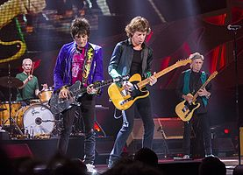](https://en.wikipedia.org/wiki/File:Trs_20150623_milwaukee_jp_105.jpg)

Charlie Watts, Ron Wood, Mick Jagger, Keith Richards

The Rolling Stones followed Dylan with a rocking set, largely from the Sixties and early Seventies. Among other tunes, they played: Like a Rolling Stone, Jumpin’ Jack Flash, Street Fightin’ Man, Can’t Always Get What You Want, Honky Tonk Women, Let it Bleed, Moonlight Mile, Bitch, Sweet Virginia, Brown Sugar, Sympathy for the Devil, Angie, and of course, Satisfaction.

The entire band was in excellent physical shape, especially Mick Jagger and drummer Charlie Watts. The aging guitarists Ron Wood and Keith Richards seemed to be as well. All of them, especially Mick, were in constant motion, except during the occasional ballad.

In the words of L.A. Times critic Randy Lewis, “His use of the surround-sound system helped achieve a sense of being enveloped by the show, which, as usual for Waters, has much to say about the encroachment of totalitarian forces on personal liberty. Ominous voices, cackles, sirens and other sound effects zoomed around the space” on all sides of us. And even though the other five bands who performed before Waters also used the video screens , Waters was the one who most fully exploited thir sheer size.

[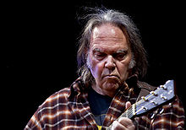](https://en.wikipedia.org/wiki/File:Neil_Young_-_Per_Ole_Hagen.jpg)

Neil Young

Neil Young opened the second night of Desert Trip as the harvest moon was rising. It was the perfect backdrop for his song Harvest Moon and his impassioned plea against Monsanto’s domination of America’s food chain with its genetically modified seeds. Neil played some of his best known music, songs like Heart of Gold, Cowgirl in the Sand, Southern Man, Cinnamon Girl, and Rockin’ in the Free World. He also played some of his more politically motivated stuff, like Ohio, Comes a Time, and Show Me. I’d forgotten what an impassioned environmental activist Neil is.

Next up was Paul McCartney, another ageing Brit who is clearly still in shape. He played for as long as the audience encouraged him, longer than any of the other bands—about 3 hours!

[](https://en.wikipedia.org/wiki/File:Paul_McCartney_-_ON_THE_RUN_-_Uruguay,_2012-04-16_(3).jpg)

Paul opened his set with A Hard Day's Night. He also invited Neil Young on the stage to perform A Day In The Life with him. They then continued on to perform a cover of John Lennon's Give Peace A Chance, more timely than ever today.

[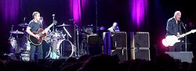](https://de.wikipedia.org/wiki/Datei:The_Who_2007_-1-.JPG)

The Who opened the third night with a strong set of some of their many great tunes. Included were I Can’t Explain, My Generation, I Can See for Miles, Who Are You, and my favorite, Won’t Get Fooled Again. Musically speaking, the Who rivaled if not surpassed the Stones for the tightest, most explosive band of the festival. Pete Townsend hasn’t lost a lick over time and Roger Daltrey can still belt out a song.

[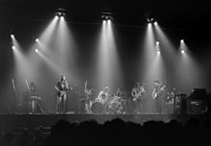](https://en.wikipedia.org/wiki/File:DarkSideOfTheMoon1973.jpg) Roger Waters, a founder of Pink Floyd, followed and closed out the show in grand fashion. It started with an ominous rumble that felt like the beginning of a rocket launch at Cape Canaveral, I know because I was there for one in 1973. This was the work of a high-powered quadraphonic sound system that was unique to Desert Trip. In the words of L.A. Times critic Randy Lewis, “His use of the surround-sound system helped achieve a sense of being enveloped by the show, which, as usual for Waters, has much to say about the encroachment of totalitarian forces on personal liberty. Ominous voices, cackles, sirens and other sound effects zoomed around the space” on all sides of us. And even though the other five bands who performed before Waters also used the video screens , Waters was the one who most fully exploited their sheer size.

In the words of L.A. Times critic Randy Lewis, “His use of the surround-sound system helped achieve a sense of being enveloped by the show, which, as usual for Waters, has much to say about the encroachment of totalitarian forces on personal liberty. Ominous voices, cackles, sirens and other sound effects zoomed around the space” on all sides of us. And even though the other five bands who performed before Waters also used the video screens , Waters was the one who most fully exploited thir sheer size.

In his 2.5-hour show, Waters went through most of the touchstone numbers of the Pink Floyd catalog: Speak to Me, Shine on You Crazy Diamond, Wish You Were Here, Pigs on the Wing, Another Brick in the Wall, Money, Us and Them, and Comfortably Numb. “Originally, much of this music provided a soundtrack for headtrips, journeys into altered states that often were the product of ingested (hallucinogenic) substances. Now Waters uses the gran stage afforded him to create shock and awe for concert audiences, a reminder that the experience of live music can provide much more than flashy costume changes, hyperkinetic choreography, and blinding pyrotechnics.

Roger Waters used his performance to take shots at Donald Trump. He used a huge inflatable pig to point out Trump’s most salient attributes: racist, zenophobe, misogynist, ad nauseum. The flying pig was cheered by many and prompted others to head to the parking lot early. I was so loud in my approval, that Sonia warned me to be careful not to get myself arrested, something that was never going to happen is that crowd.

Five days after we drove back from Coachella, we flew up to San Francisco for five days at the end of October, we drove a rental car up to Santa Rosa to see Uncle Pete’s widow Lillian and down to San Francisco to see cousin Margaret and her husband Jeff as well as old prep school friend Michael Fogarty. We got in another beautiful hike in the Golden Gate National Recreation Area.

[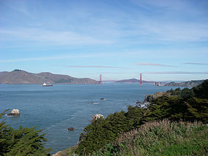](https://en.wikipedia.org/wiki/File:Golden_Gate_-_Lands_End_-_Point_Lobos_2009.jpg)

Golden Gate Bridge & entrance to San Francisco Bay

In early December we flew to San Francisco again and rented a car to drive four hours north to Chico and Redding to see Aunt Signe and old friends from my years in Redding.

2016 has been another good year for son Jakob. He continues his private practice in clinical nutrition and herbal medicine, helps head up the herbal medicine team for the non-profit integrative primary care unit, Occupy Medical, and has recently embarked on a new professional journey with San Francisco-based start-up, Vida Health, a digital platform for chronic disease care and wellness coaching. He continues to play music, botanize the Pacific Northwest, and following in Papa Tryg's footsteps has recently taken up photography. His ladyfriend of the past year, M.K. Britton, a South Carolinian transplanted to Portland, OR, has recently moved down to Eugene and taken a job with Willamalane, a Parks and Recreation non-profit. Like Jakob, she is an avid lover of the outdoors, and between working on fine arts projects, spends much of her time riding horses and rock climbing.

Son Ethan, a computer programmer, is currently making a job change. His wife Ami continues working as a therapist at Lane County Behavioral Health and Peace Health hospital in Eugene, Oregon. Zara, 11; Ürah, 10; and Pan, 7 are all doing very well in school. Zara’s primary interests are gymnastics and dance. [*Copy for Ürah and Pan was unfortunately lost.]*

Daughter Isis’s finally surgery to take the hardware out of her femur was completed successfully, so the long process of getting her broken leg mended is finally over! She anticipates returning to the “friendly skies” early in the New Year. In the meantime, her longarm quilting business has been good.

Sonia’s historic novel about her family during the 20th century and earlier in Brazil and Portugal was translated from Portuguese into English this past year. I have edited the translation, which was done by an American who has spent almost all of his life in Brazil. Sonia and I will see about publishing it in the US during early 2017.