2017 ANNUAL NEWSLETTER
All things considered, this past year was a good one. Other than Laguna Beach and Rio de Janeiro (twice each), we visited the Amazon River Basin, Houston, Eugene, Rome, Florence (Italy) and Croatia. There have been some health issues, first with Sonia (sciatica) and then her older sister Ilma, who has been battling cancer.
While in Rio, I flew to Manaus, at the heart of the Amazon basin, a 4-hour direct flight. Sonia had been to Manaus several times during her career and I had been wanting to go there for some years, so I took the opportunity to do it on my own. The first day I took a boat to “the meeting of waters,” the confluence of the dark (blackwater) Rio Negro and the pale sandy-colored (whitewater) Amazon River, called Rio Solimões in Brazil. The two rivers run side by side without mixing for about 6 kilometers (km). This phenomenon is due to differences between the two rivers in temperature, speed and density. The 82°F Rio Negro flows at about 2 km/hr. while the 72°F Rio Solimões flows at about 5 km/hr. Later I chose to swim in the Rio Negro!
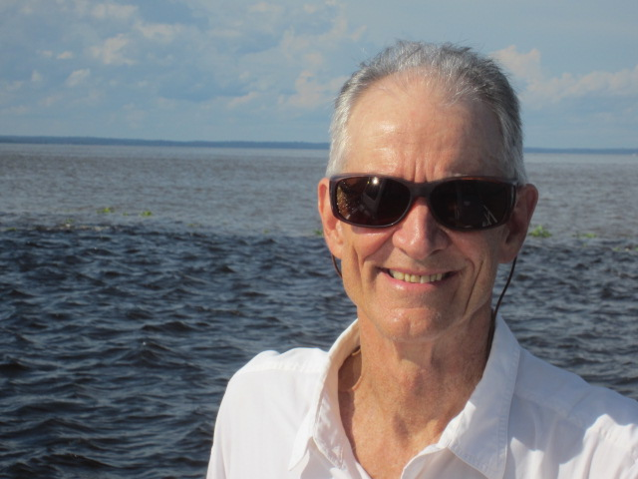

As shown on the map on the next page, the Rio Negro’s headwaters are located in the northern and western part of the Amazon Basin in Colombia, Venezuela, and Guyana; the world’s 8th largest river, the Orinoco, largely drains this area. The Rio Solimões is colder and faster than the Rio Negro because it drains the Andean region from the southern and western part of the Amazon Basin in Bolivia, Peru, Ecuador, and southern Colombia. The map shows that in addition to the whitewater Solimões and blackwater Negro, clearwater rivers also drain the Amazon Basin. These rivers flow north off the high central plain of Brazil itself, starting from Brasilia. These are the rivers that are most dammed for hydropower in the entire Amazon Basin: the Tapajos, Xingu, and Tocantins. Put it all together and you have a river that is by far the world’s largest, and when you go to Manaus, you see it in all its majesty.

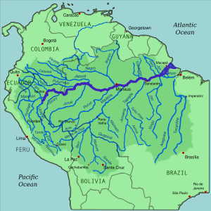
The Amazon Basin, about 70% of which is in Brazil
In 2008, when I first visited the Amazon, I wrote that “Its volume makes up roughly 20% of the total contribution of the world’s rivers to our oceans. The top 10 rivers by volume (measured in thousands of cublic meters per second) are the Amazon 209 tcms, Congo 41 tcms, Ganges 38, Orinoco 37, Madeira 31, Yangtze 30, Negro 28, Plata 22, Yenisei (in Russia) 20, and Brahmaputra 20 cms. Three of the above-named rivers, with combined annual runoff of 96 tcfs, are tributaries of the Amazon. That puts the Amazon and its top 3 tributaries at 305 tcms with the rest of the top 10 at 171 tcms. A bit below the top ten in tcms are the St. Lawrence, Mississippi, Ganges, and Mekong rivers. A final statistic to boggle your mind is the average annual rainfall across the enormous Amazon basin: 440 inches (or 36 feet) per year!
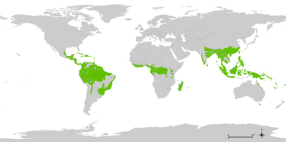
Worldwide distribution of tropical moist broadleaf forests

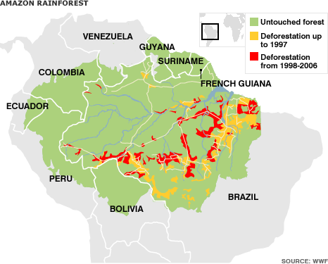
As shown above, 17 percent of the massive Amazon rainforest has already been destroyed by loggers and farmers, but much more will likely be lost before new protective laws can be passed and enforced. Much of the political power in Amazonia is in the hands of big corporate growers, and the loggers are continuing to flagrantly disobey the law when they clear the land for agriculture, although the Brazilian federal government has finally begun to take enforcement action. Sadly, things have changed for the worse recently. The current president of Brazil, Michel Temer, maintains his power in part by catering to the “ruralistas” in the federal legislature. These people are the equivalent of Western Republicans in the US, and on Temer’s watch, things have been getting much worse on this and other environmental issues.
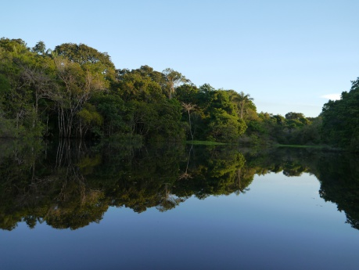
Blackwater flooded forests in the Amazon are called igapós. Immense areas on the margins of the Rio Negro are flooded seasonally for up to six months. Leaf litter sinks and releases tannins that give the water its dark color and reflective quality. When the wind dies down, the surface of the water is like black glass It makes ideal habitat for young fish such as this little piranha, which we cooked and ate afterwards. Not a lot of meat, but very tasty! (Yes, this is the one we call pirana, that’s got lots of sharp teeth for feeding on flesh!)
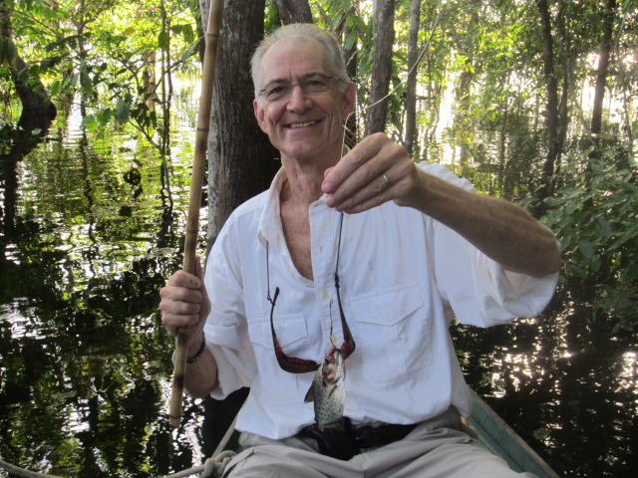
The next photo is from an exhibit I was lucky to see in Manaus. Its title reminded me of “Fish vs. People”, the battle cry of the farm workers who were bussed to Sacramento during our successful campaign to reform the federal Central Valley project in the early Nineties. Our response was to bus commercial fishermen to Sacramento to show that fish had economic value and of course needed water to survive. The Fish and People exhibit showed the interdependence of the upper Negro indigenous peoples and fish, which along with manioc, has long been a basic staple of the tribal diet. The photo shows the placement of fish traps in wiers built by various tribes at waterfalls in the upper Negro River region. These traps are placed at the time of March floodwaters when the fishing is the best.

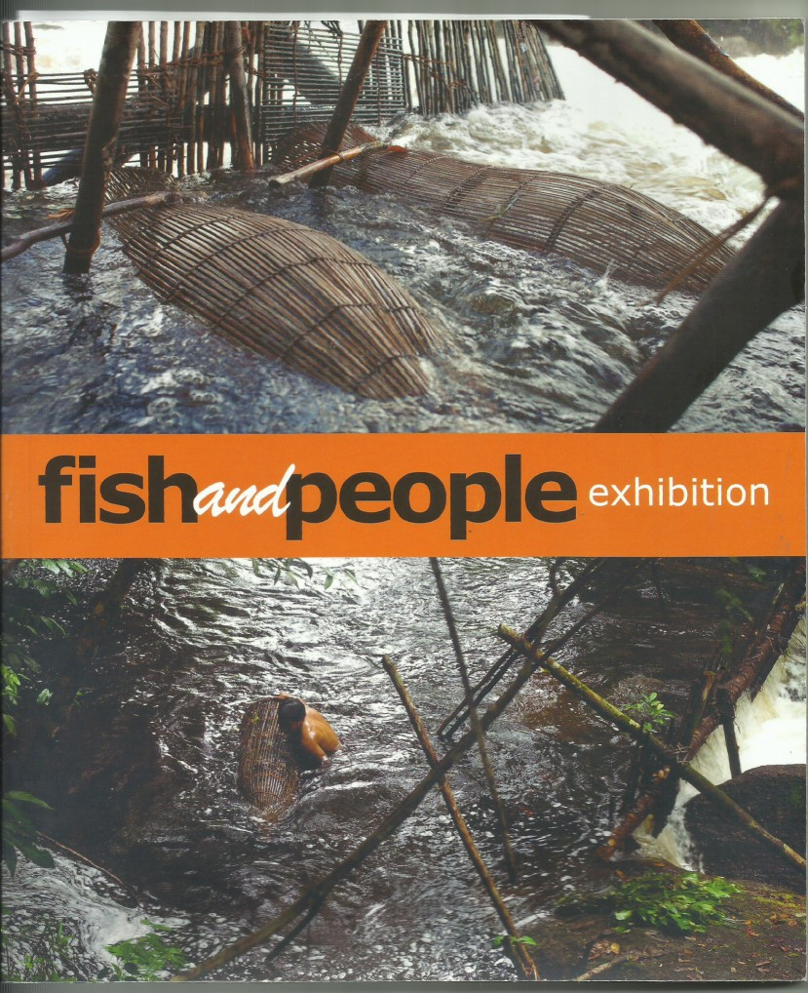
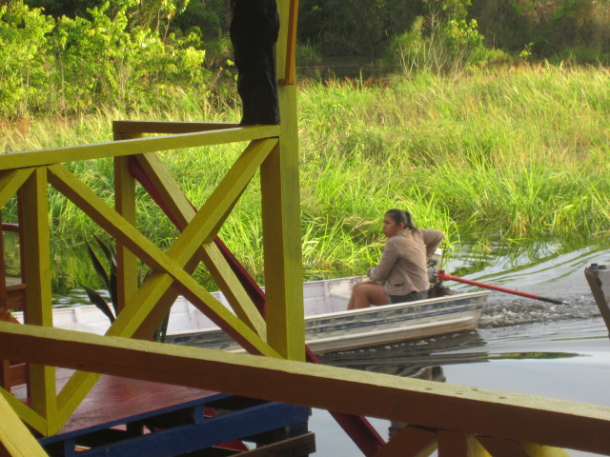
. I stayed in a jungle lodge built in a roadless area where everyone on the staff got to and from work by boat.
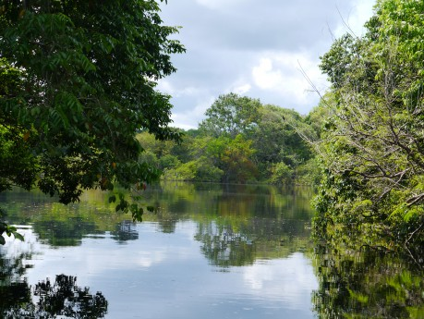
The idyllic view of the Rio Negro from my room.

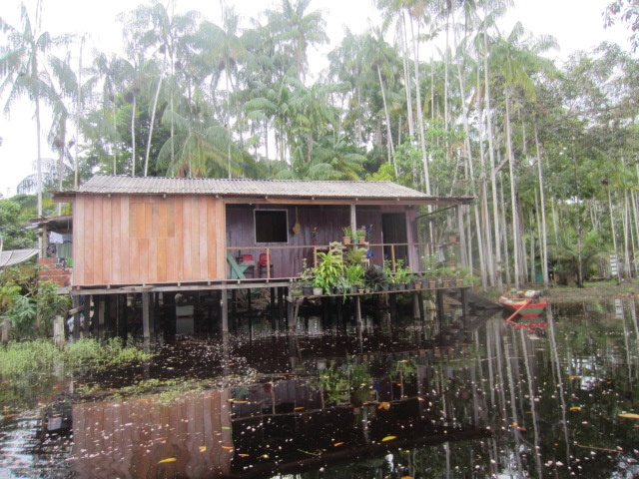
To stay above the seasonally flooding of the river, everything is built well above on pilings. Note the leaf litter floating on top. After the leaves sink, they decompose and give the Negro its acidity and dark color.
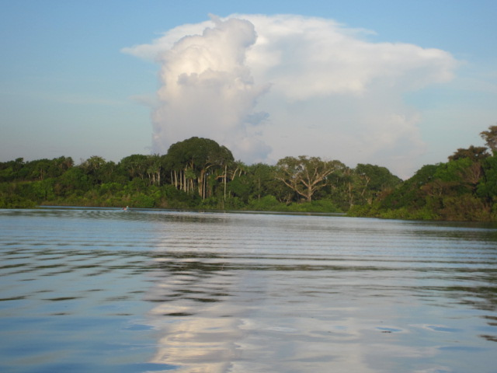
For a week, we spent long days moving around on the river. The two biggest trees on the far bank here in the center of the photo are Brazil Nut and Kapok trees.
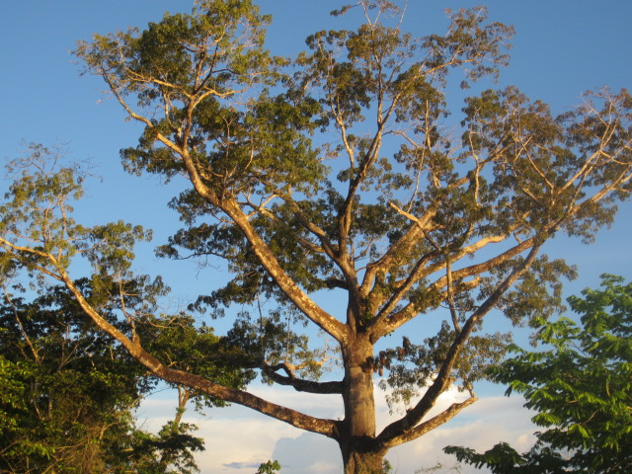
The Kapok tree was festooned with yellow-rumped cacique nests and associated wasp nests. The song of the male bird is an unmistakably brilliant mixture of fluting notes with cackles, wheezes and sometimes mimicry, because of which our guide called it a mockingbird. An active colony can be heard from a considerable distance, which attracted us to investigate close-up.
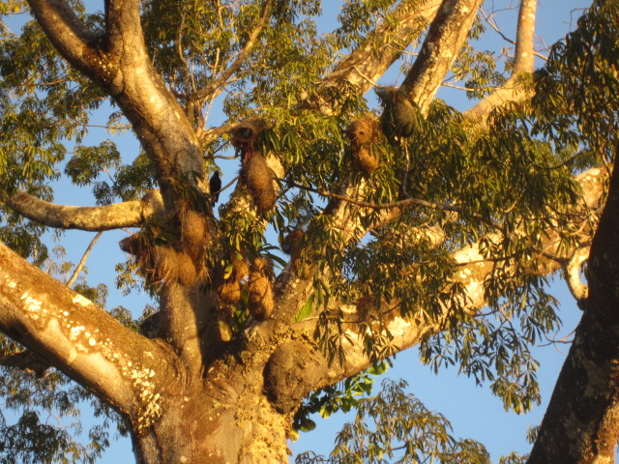

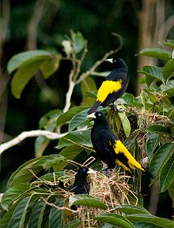
Yellow-rumped caciques

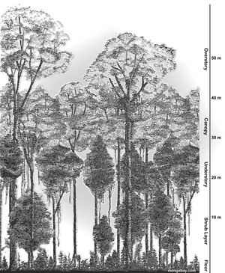
The Amazon rainforest has four layers, each of which has its own unique ecosystem. The top layer is the emergent (or dominants) where the tallest trees are found (up to 200 feet tall). Many birds, such as eagles and parrots, reside in the emergent. The primary layer is the canopy where about 70 to 90 percent of all rainforest life resides. Plants in this layer have a large amount of fruit, seeds and flowers. Birds such as the toucan live in the canopy. The understory is the next layer where very little sunshine reaches; only about 2 to 15 percent of sunshine reaches the understory. The darkest layer is the forest floor, where most of the larger animals live. With multiple environments, the Amazon rainforest is able to provide a home to thousands of birds with different survival needs.
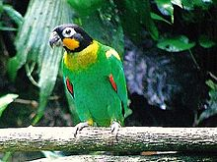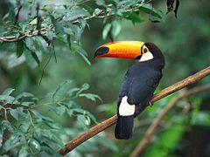
orange-cheeked parrot toucan
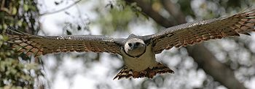
The harpy eagle, rare throughout its range, has a wingspan of up to 7 feet.

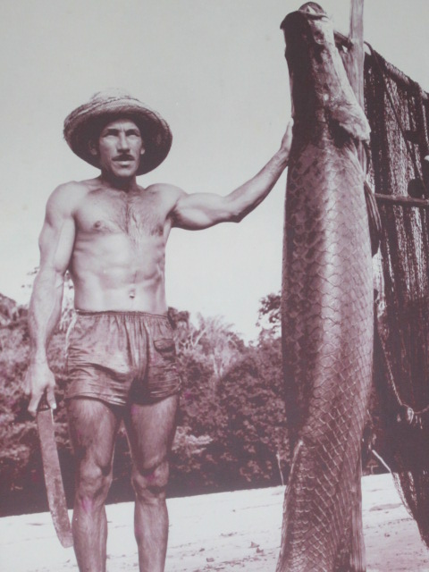
I spotted the above photo hanging on the wall of the office where I waited for my trip to the “meeting of waters”. The pirarucu is a bony tongue fish native to the Amazon basin. It is one of the world's largest freshwater fishes, reaching as much as 3 m (9.8 ft). It is an important food fish in Brazil, but its native range has declined due to overfishing and habitat loss. Though it has gills, the pirarucu surfaces to breath using an air bladder instead of lungs.
The activity below was billed as “swimming with the dolphins” but was more like feeding sardines to the dolphin, actually a boto, a freshwater pink dolphin that occurs only in the Amazon region. My Argentine fellow travellers and friends, a father and son named Pablo and Matías are examining a boto in the Rio Negro.
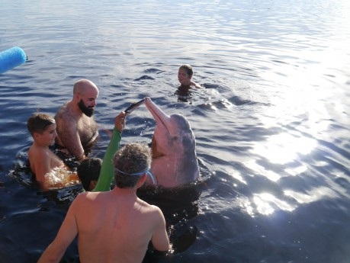
The Amazon river dolphin is a species of toothed whale. Three subspecies are currently recognized and are located in the Amazon basin, the upper Madeira River in Bolivia, and the Orinoco basin. This is the world’s largest species of river dolphin, with adult males reaching 185 kilograms (408 lb) in weight, and 2.5 meters (8.2 feet) in length. While in the water the boto, I became well aware of his size and strength when he jostled me a bit while moving his position to take several different sardines that were offered to him to keep him interested while he was being photographed.
Like other toothed whales, The Amazon pink river dolphins have a “melon”, an organ that is used for bio sonar. The boto’s large fins, unfused vertebrae, and size allow for improved maneuverability when navigating flooded forests and capturing prey.

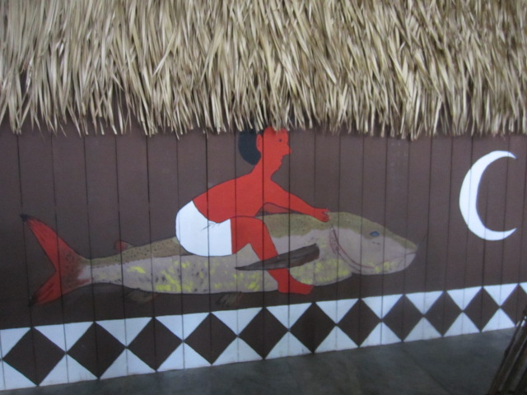
This wall of a Maloca or Amazon Indian ancestral long house on display in the Fish and People exhibition in Manaus depicts a person riding what appears not to be a whale or dolphin, but a large fish, possibly a pirarucu.
originated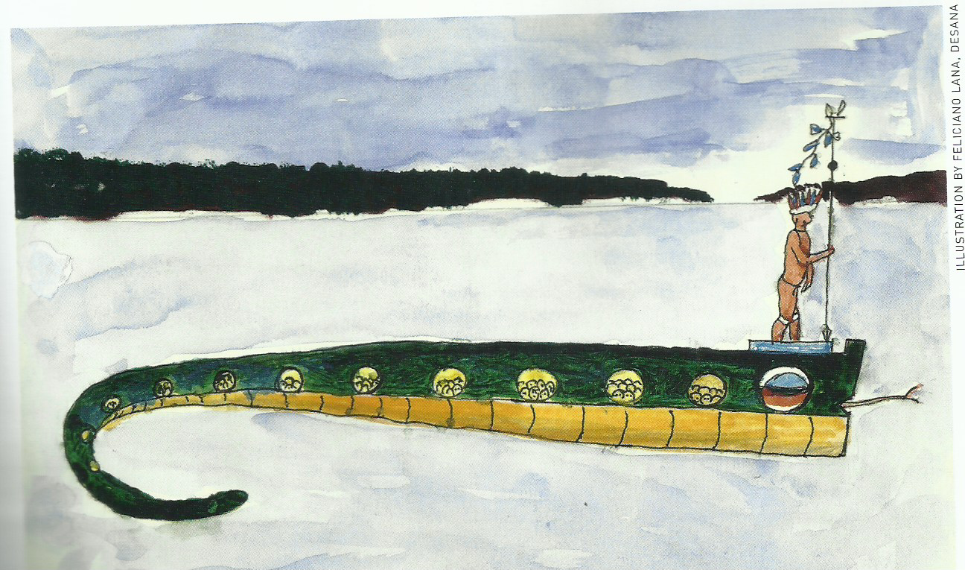
This painting from the same exhibition is titled “Serpent Canoe of Transformation”. In this upper Negro River Indian myth, humanity originated when people were transported in a serpent canoe across the Lake of Milk to their ancestral homeland. People can be seen being transformed as they look through the portholes of the serpent canoe.
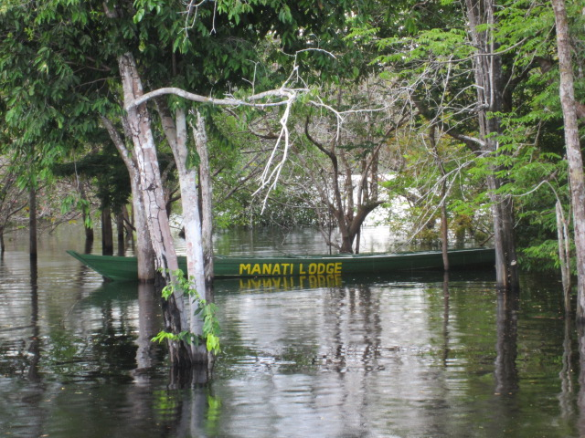
Made from hollowed out hardwood trees, canoes are typical Amazon transportation. Very long and narrow, they can be used for touring the river as I did, or for transporting goods such as logged wood to market in Manaus. It is very hot and humid in equatorial waters, and I got a touch of sunstroke from the long hours on the river in a canoe without a canopy for shade. But it only put me out of action for a day.
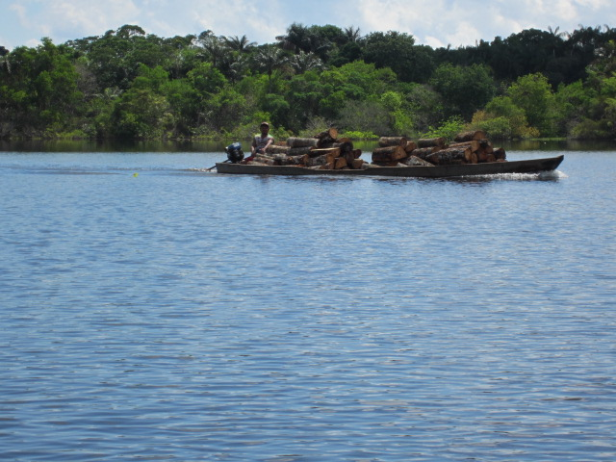
The mounted Tucunaré shown below is a food and game fish that can weigh as much as 30 pounds and reach a meter in length. I wasn’t there in the right season, but I’d like to go back sometime to go after one of these, with the right tackle of course, not a little bamboo rod with no reel like I used for the piranha!
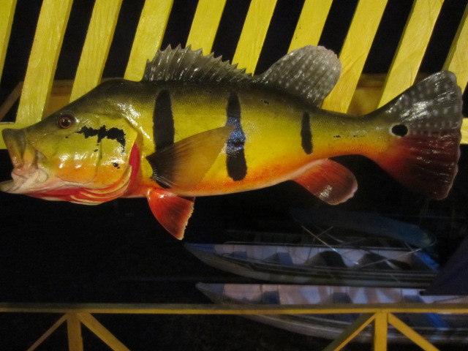
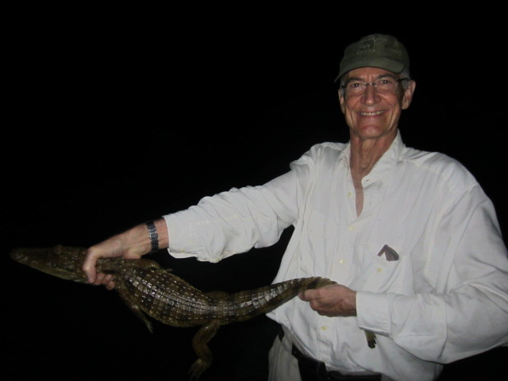
One night we went out at dusk to cruise the riverbank. After dark, the guides used a flashlight to spot the beady eyes of caimans lurking in the underbrush. I knew the guide who was operating the outboard motor, a Portuguese-speaker named Noel, was very good at calling Caimans as I could hear them answer him. The English-speaking guide, appropriately named Nigel, needed to be very quick to safely grab these big reptiles. I quickly learned the yearling gator he snatched up was quite strong. While I held him for the photo, he must have felt me relax a smidgeon as he tried an escape. This naturally had the effect of making me tighten my vise grip on his tail and particularly his neck.
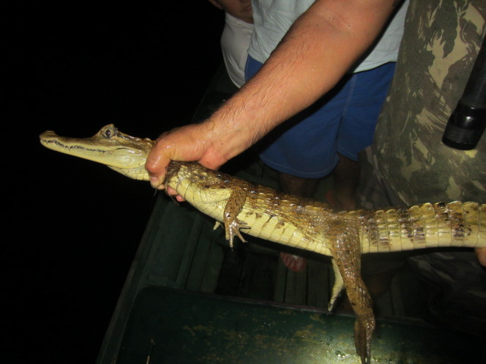
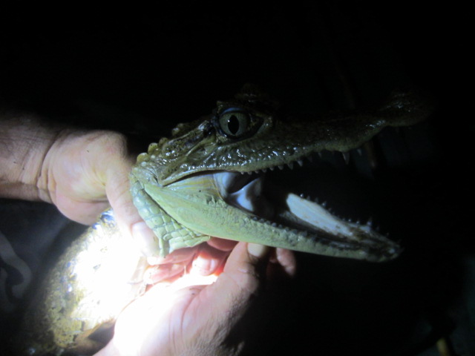
My reflex action prevented him from whipping me with his quite strong tail or biting and clamping down on my hand with his equally strong jaws. This experience taught me not to fool around with gators—even smaller ones can be fearsome opponents if they managed to break your grip!
We also spent some time on land, where the heat, humidity and animals were certainly no less forbidding than on or in the water. The crocs actually invaded what little land we were perched on at the lodge. Their favorite time to invade in search a stray pet or whatever might be available was in the predawn hours. One night the lodge dog—who stayed well up toward back, land side of the building, woke me up with some urgent barking. Turned out a jacaré or two had come on the beach to see what they could find for breakfast!
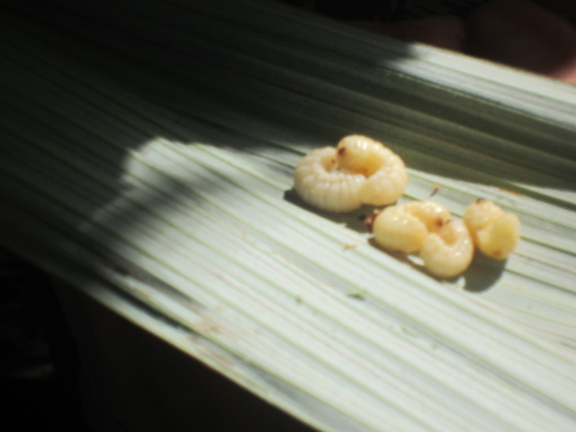
On a trail hike one day, we focused on jungle survival. I sampled these grubs to see how they tasted. Not bad really.
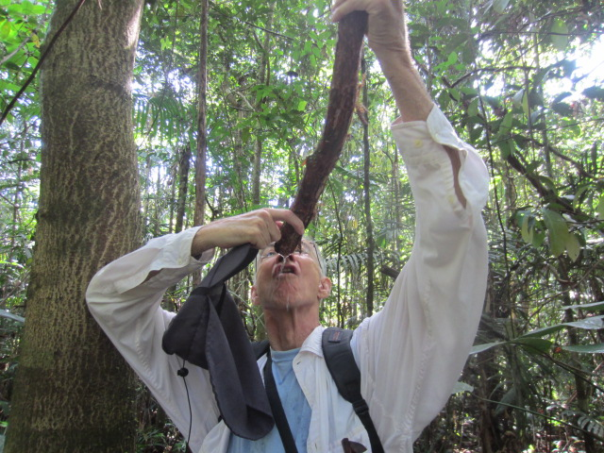
Water was to be had by taking a machete to a certain tree filled with pure water. Very thirst quenching!

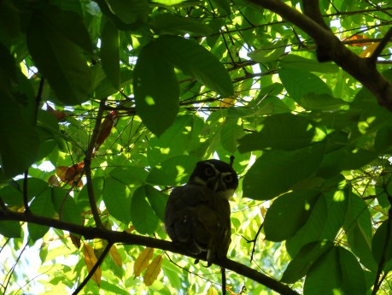

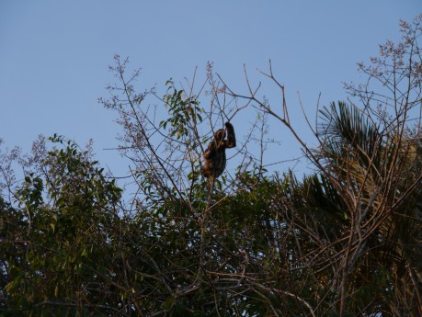
Three-toed sloth (here and closer-up below)
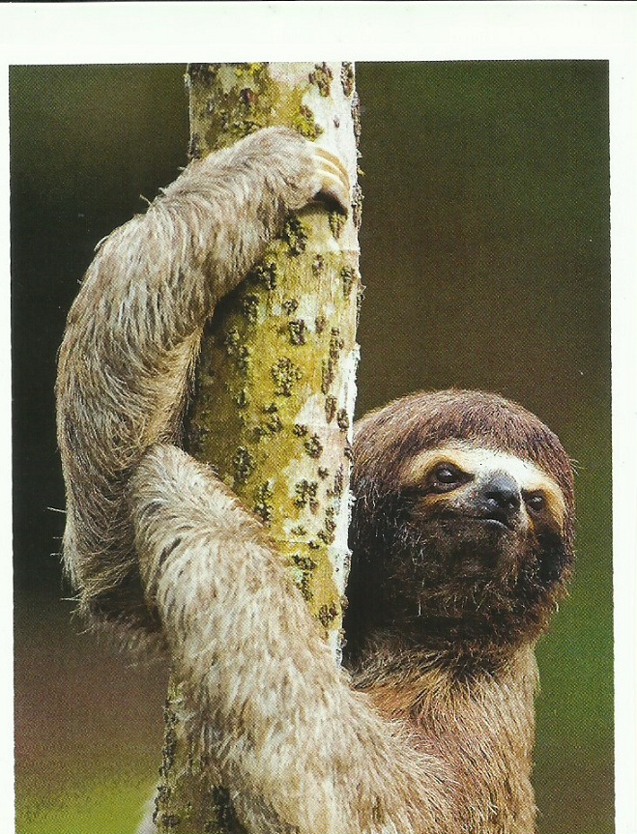

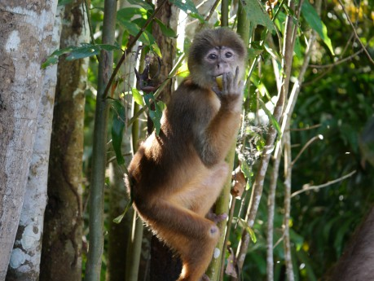
These monkey photos reveal the secret to interacting with them: offer bananas
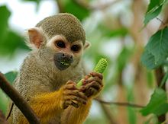
Spider Monkey

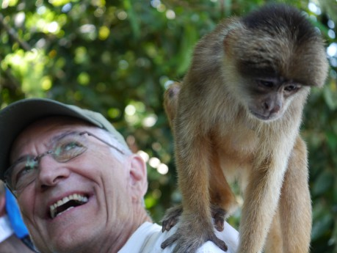
This shows what happens after you offer them bananas: they drop from the trees into your boat to search for more! After a week at the jungle lodge, I returned to Manaus to visit some of the excellent natural history and Indian museums, as well as the Teatro Amazonas, built during the Rubber Boom of the late 18th century.
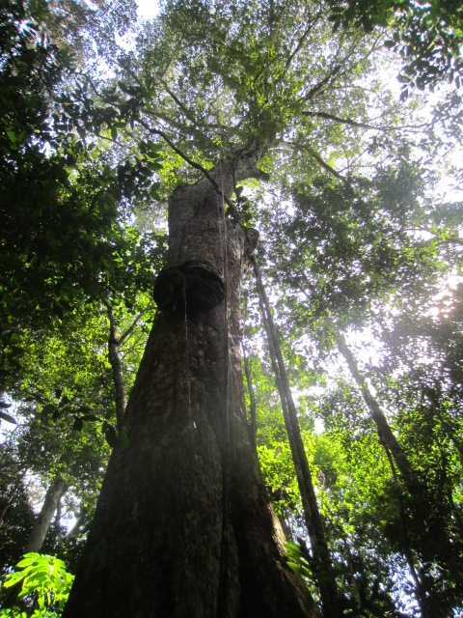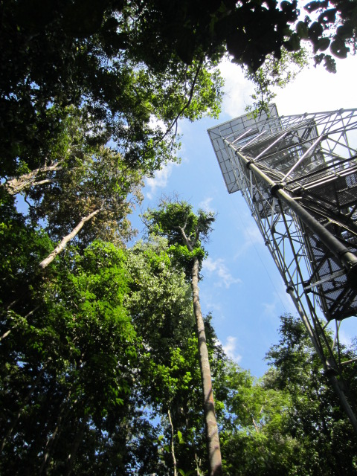
A giant tree and forest observation tower, a good climb to get above the forest canopy.
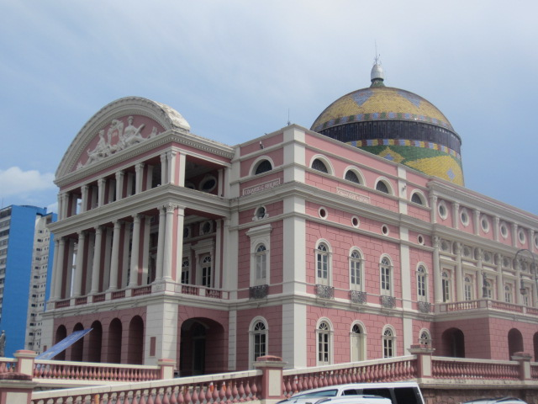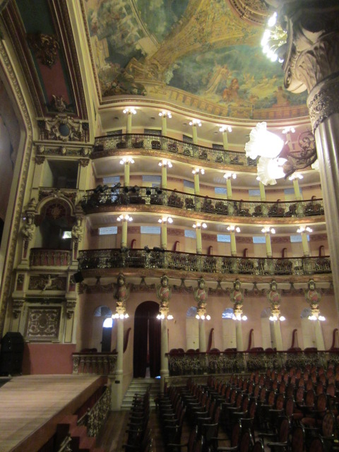
Amazon Opera House, where I attended an interesting dance show targeted to the interests of the common folks. Waiting on line, I “hammed it up” with a local family, making them laugh at the crazy gringo.
My trip was a great success as I was able to learn a lot about the world’s greatest river, its natural and anthropological history, and its people. I would like to return at some point to learn more in the future.
In the Path of a Total Eclipse of the Sun
One August 11, we returned from Brazil to southern California. About a week later we flew up to Eugene, Oregon to get in position to observe the event of a lifetime—a total eclipse of the sun—from within the 70 mile-wide path of totality. Prior to this event, no solar eclipse had been visible across the entire contiguous United States since June 8, 1918.
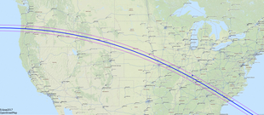
The path of totality across the United States
Billed as “The Great American Eclipse”, the total solar eclipse of August 21, 2017 hit land in Oregon, passed across the entire country, and was seen by a large percentage of 350 million Americans. It turned out to be the second such eclipse I’d been lucky enough to see under perfect weather conditions, with nary a cloud in the sky! We drove from Eugene to Lebanon, Oregon very early in the morning the day before the eclipse. As luck would have it, when the sun rose we were parked facing west (as we would for the eclipse) in front of the house of a friend of the family who’d invited us to stay there. Later in the day, when we determined this wasn’t an ideal location from which to view the eclipse the next day, we found a great spot from which we would be able to view the location of the eclipse if the sky turned out to be clear. There were clouds the day we arrived, but on eclipse day, the sky was clear at sunrise!
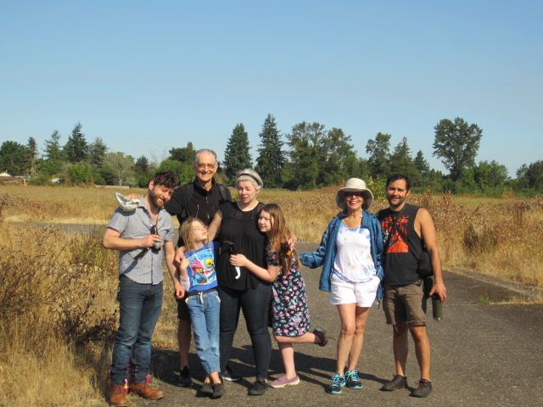
Waiting for the eclipse to start: Ethan, Pop-pop, Pan, Ami, Urah, Nana, and Yak facing the western sky.
As the eclipse began, it was imperceptible to us. After a bit, looking through the welder’s glass I brought along, I noticed that a “bite” had been taken out of the solar disc. Gradually the shadow of the advancing, faster moving moon covered more and more of the sun. Then, more than an hour after the partial phase of the eclipse had started, daylight began to fade very quickly. In these last few minutes before the total phase of the eclipse, the darkened sky and the quieting of nature produced an eerie effect.
As the narrow crescent of the Sun finally began to disappear—about ten seconds before totality—small beads of irregularly spaced light remained visible for a few seconds longer around the disappearing edge of the Sun. They were the last few rays of sunlight shining through valleys on the edge of the Moon. Then a single point of sunlight remained—the "diamond ring effect”—as the last ray of sunlight vanished.
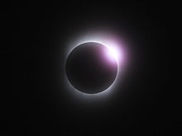
The Moon's shadow, racing along the Earth at speeds up to several thousand miles per hour, suddenly caused a swift and dramatic nighttime effect, though perceptibly not quite as dark as night. Suddenly, the breeze died, the temperature dropped noticeably, and the air became completely still. The silent stillness was unearthly. The startling onset of totality and strange appearance of everything around us created an effect unlike anything else I had ever seen other than a total solar eclipse.
In the center of this darkened sky was a weirdly spectacular sight—the corona of the Sun, which view could observe with our special eclipse glasses. It was pearly white, shining in all directions around the darkened solar disk.
A million times dimmer than the Sun itself, the full glory of the corona is visible only during the “totality” phase of a total solar eclipse. This photo doesn’t do it anywhere near justice, but it will give you an idea what the corona looks like.
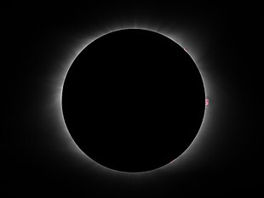
As the science writer Dennis Overbye observed, “you always knew (the corona) was there, a hidden vibration in your soul, the intuition of something unseen, a mandala meaning whatever you want it to mean.”
And then, after a minute and thirty-eight seconds, the shadow of the moon passed and along with it the strange daytime darkness. A bright speck of sunlight flashed into view at the western edge of the Sun as the corona disappeared. Totality had ended. The same events that preceded totality now occurred in reverse order and on the opposite side of the Sun. Daylight returned as more and more of the Sun was gradually uncovered while the Moon passed away from it. The birds began to sing again and the bees to buzz as the wind arose once more. “Reality” had returned, but—make no mistake—total solar eclipses are real too, if you’re lucky enough to get to the right spot at the right time to see one. Take it from a confirmed “eclipse chaser”! I should warn you, though—they can do strange things to you. This is what I looked like after absorbing my first total eclipse of the Sun!
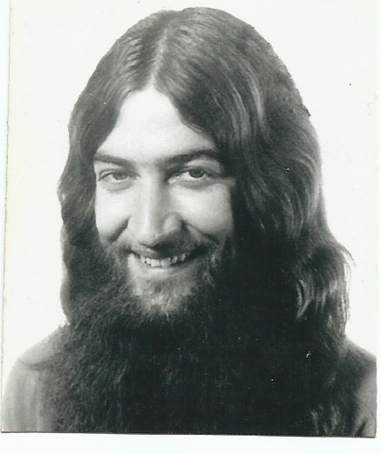
Portrait from the early 1970’s.
Isis is happily back to work at United out of Chicago, and her long arm quilting business continues to keep her busy on the side (ilwanderer@aol.com). Ethan has settled into his work at Concentric Sky. Wife Ami is a therapist at Peace Health Hospital in Eugene. Yak continues nutrition counseling with Vida Health (https://vida.com). Girlfriend M.K. Britton continues working for a Eugene Parks and Rec. district. Like Yak, she is an avid lover of the outdoors, spending her off time rock climbing and horseback riding. Ethan and Ami’s kids, Zara 12, Urah 11, and Pan 8, are doing well in Montessori School in Eugene and another charter school in Cottonwood, California. Photos on next page (clockwise): Sonia, Ethan, Yak&M.K., Aunt Sig (passed away this year), Isis (photo by Karen Sletteland), Sonia,Urah&Pan.

