2017 Newsletter, Part 2 – Italy & The Dalmatian Coast
A month later we flew to Rome for a week, then crossed the Adriatic Sea to Dubrovnik. We spent a couple of weeks there and cruising the Croatian coast as far north as Split, and then re-crossed the Adriatic to Florence for our final week of the trip. (We decided to skip Venice after reading reports about the hordes of tourists there.)
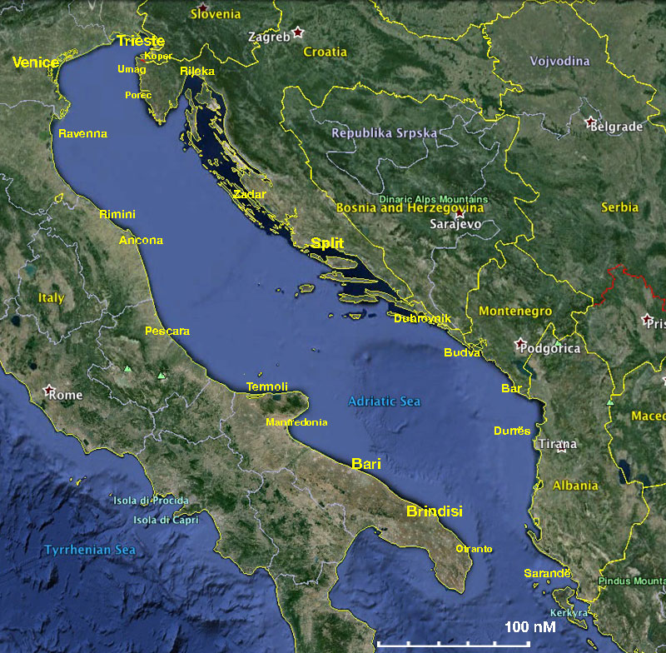
I hadn’t been to Rome since 1962. I was 16 years old at that time, so I had changed a lot, but so had Rome. The Coliseum and the Roman Forum were much the same, as was the Vatican, but there was huge growth in the number of visitors there. This was seen especially in places like the Coliseum and Trevi Fountain.
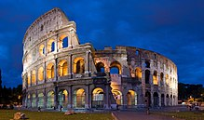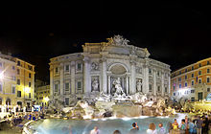
The incredible press of humanity at the Vatican was the worst I had seen since 1974, when I was in Cuzco for the winter solstice the way it had been observed by the ancient Inca. Around the Sistine Chapel, one could only move forward in a shuffle step, fighting to stay with one’s guide. There was a rigorously enforced photography ban in the Sistine Chapel as the Japanese had apparently bought the photographic rights! The photos are courtesy of Wikipedia; on the right is of Michelangelo’s “The Last Judgment”.
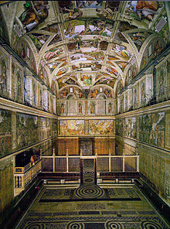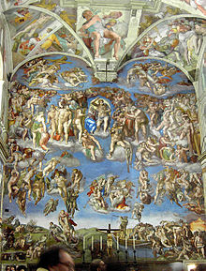
The Borghese Gallery was managed much better, though without the Roma Pass and a reservation, it would have been a different story.
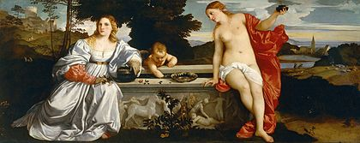
Sacred and Profane Love by Titian. c. 1514
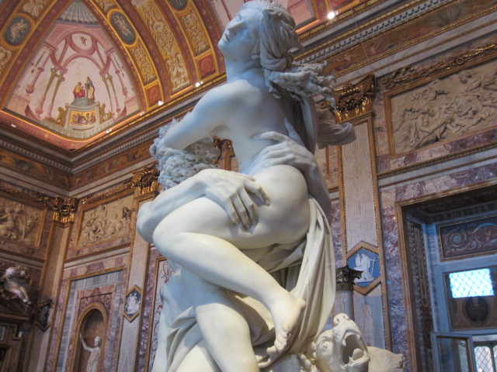
The Rape of Proserpina by Gian Lorenzo Bernini 1621-22,
one of the most dynamic works on display at the Borghese.
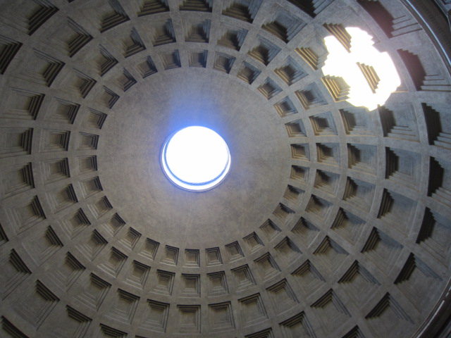 Almost two thousand years after it was built, the Pantheon's dome is still the world's largest unreinforced concrete dome. The height to the oculus and the diameter of the interior circle are the same, 142 feet (43 m). It is one of the best-preserved of all ancient Roman buildings, in large part because it has been in continuous use throughout its history. The oculus is the main source of the natural light which illuminates the interior of the building.

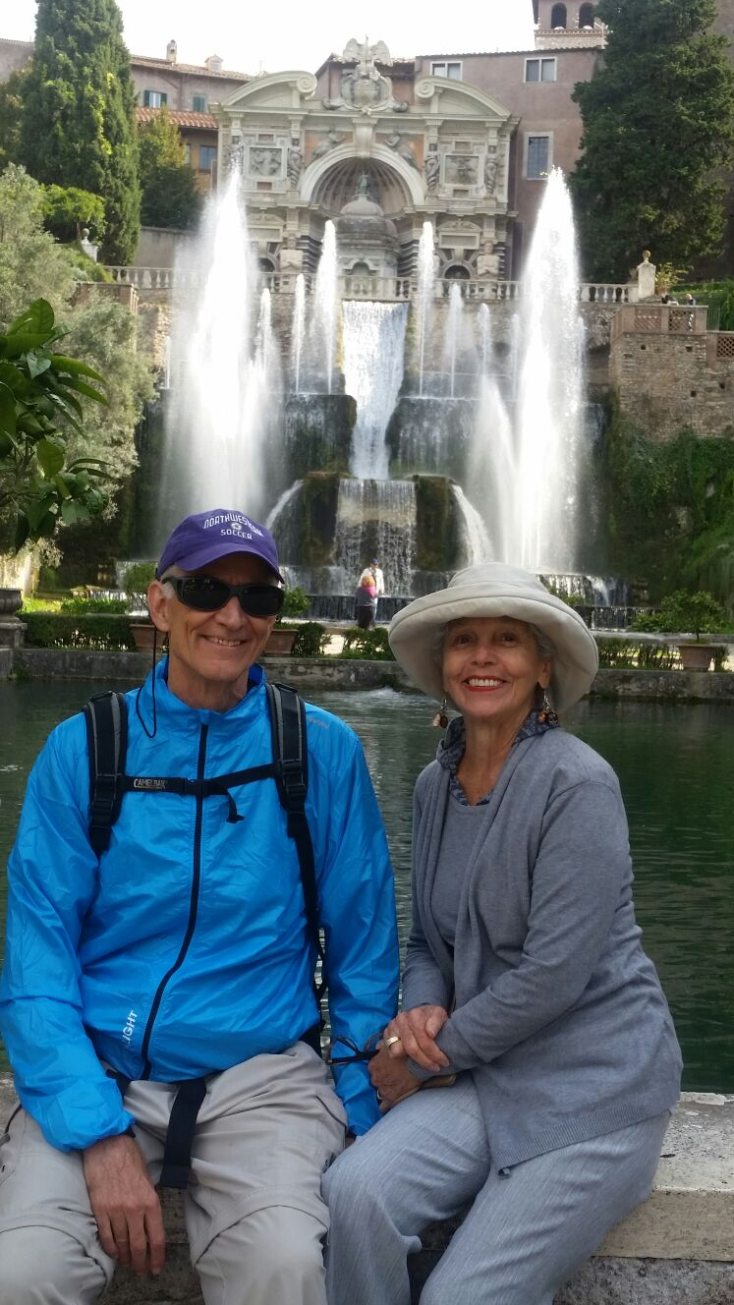
While in Rome, we made a day trip to The Villa d'Este, a 16th-century villa in Tivoli, famous for its terraced hillside Italian Renaissance garden and especially for its profusion of fountains. Our trip was guided by a Brazilian friend of Sonia’s, Mônica Staretz, who has lived in Rome for many years. Villa d’Este is now an Italian state museum, and is listed as a UNESCO world heritage site.
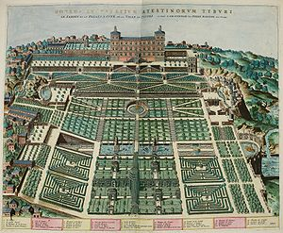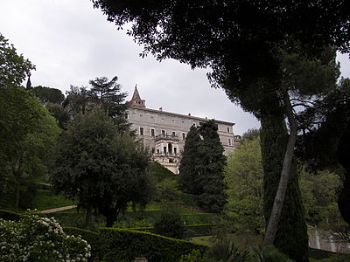
plan of the villa and gardens the villa seen from the gardens

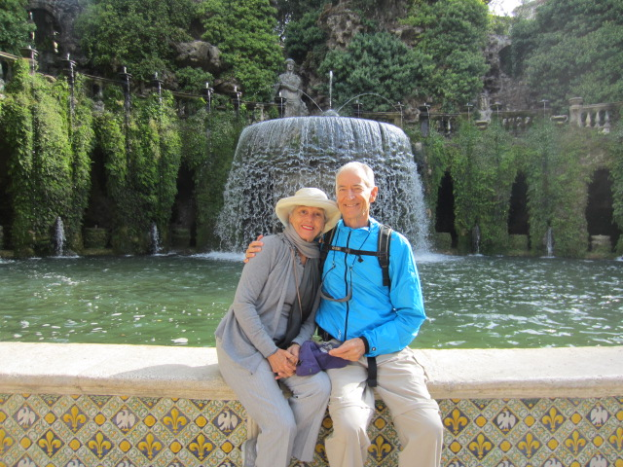
(photos of us at Villa d’Este courtesy of Mônica Staretz)
The short flight from Rome to Dubrovnik took us on a route just north of the deepest part of the Adriatic as you can see on the map on page 24. In 1979, the city of Dubrovnik joined the UNESCO list of World Heritage Sites.
The prosperity of the city was historically based on maritime trade; as the capital of the maritime Republic of Ragusa, it achieved a high level of development, particularly during the 15th and 16th centuries, as it became notable for its wealth and skilled diplomacy. Prior and subsequent to that, the city was influenced by the Greeks through the islands of Korcula and Vis, the Byzantine Empire, Venice, Hungary, the Ottoman Empire, and was part of the Austro-Hungarian Empire and Yugoslavia.
In 1991, after the break-up of Yugoslavia, Dubrovnik was besieged by Serbian and Montenegrin soldiers for seven months and suffered significant damage from shelling. After repair and restoration works in the 1990s and early 2000s, Dubrovnik re-emerged as one of the top tourist destinations in the Mediterranean. This has meant absorbing thousands of visitors each day off large cruise ships, so we stayed outside the old city on the Lapad Peninsula and rode a public bus to the old city in early morning or late afternoon.
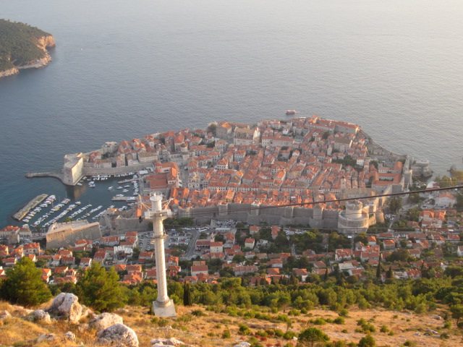
From the mountain reached by cable car, we got a great view of the Old City of Dubrovnik and its inland protective wall could be easily observed. The old port is on the left side, with the end of Lokrum Island at top left. We also took this shot of the island from above Dubrovnik. It is just 600 meters off Dubrovnik and a great place to hike as it is a roadless park. The high point is about 100 m. above the sea. There was a Benedictine monastery founded there in 1023. According to local legend, just before the monks left in 1808, they put a curse on any future travellers to the island. The effectiveness of this curse was borne out by a fall Sonia took above the monastery, spraining an ankle that put her out of action for several days afterwards!
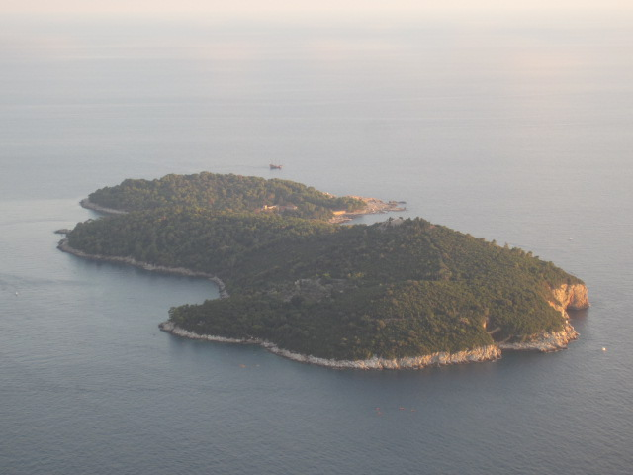
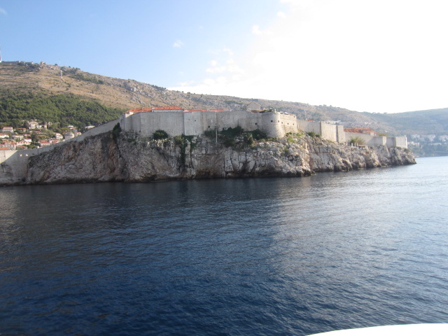
Dubrovnik fortified Old City wall viewed from the sea
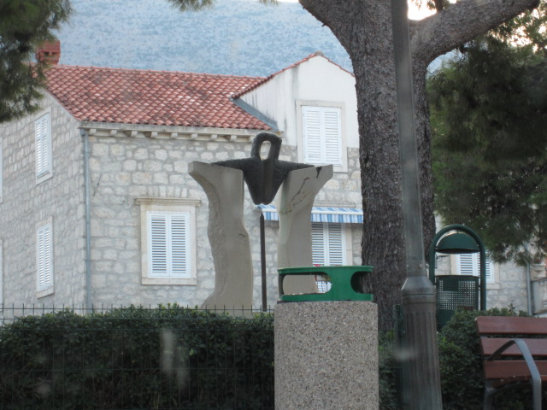
By boarded our ship in Dubrovnik and our first overnight stop was at a small mainland village called Slano. I took this photo through one of our stateroom’s portholes. We got the feeling from the imagery (that’s a sword hanging down in the center of the sculpture) that it was a war memorial. Sure enough we later found internet proof that it marks the Croation War of Independence fought in 1991-2001.
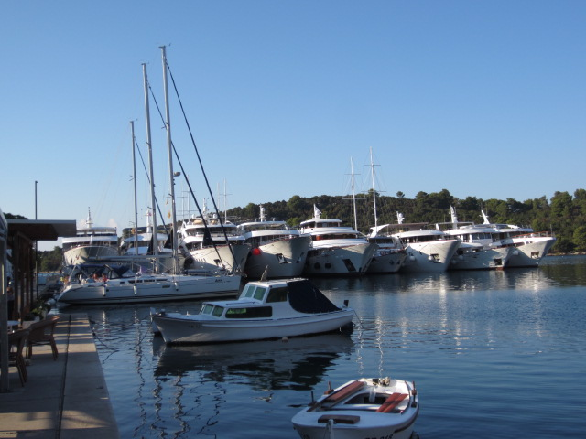
The first island stop on our cruise was Mljet. Here you can see the formation that occurred with a group of same-sized ships many nights during our cruise. The first boat to the dock (usually ours) ties up there, the next boat ties to the one already there, and so on. Passenges on the outer boats then walk through the ones on the inside to get to the dock. Not the best arrangement, but it worked passably well.
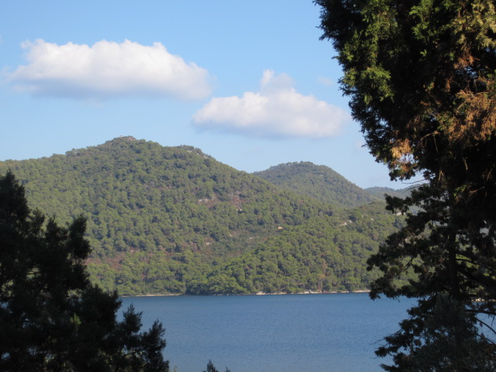
On Mljet we hiked to a picturesque lake and took a ferry to an island there.
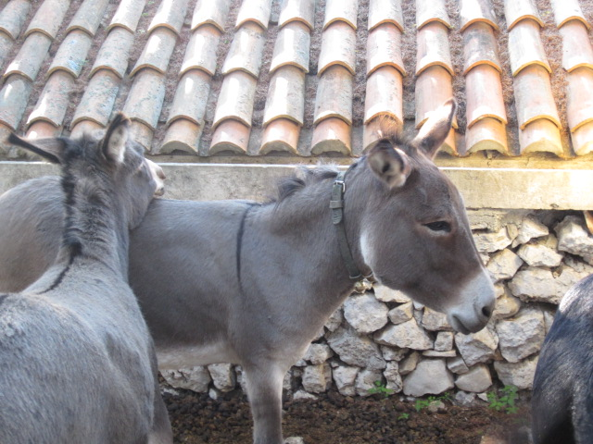
These little burros lived on the island.

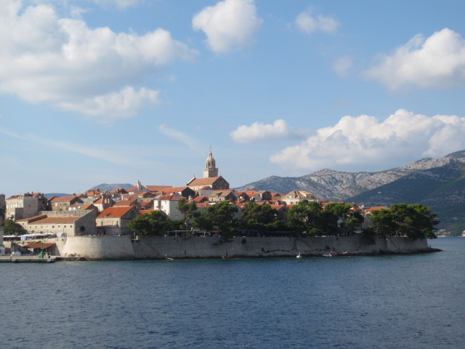
Our next island was Korčula. Here we are arriving there.
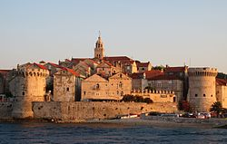
Earlier photo of Korčula Old Town

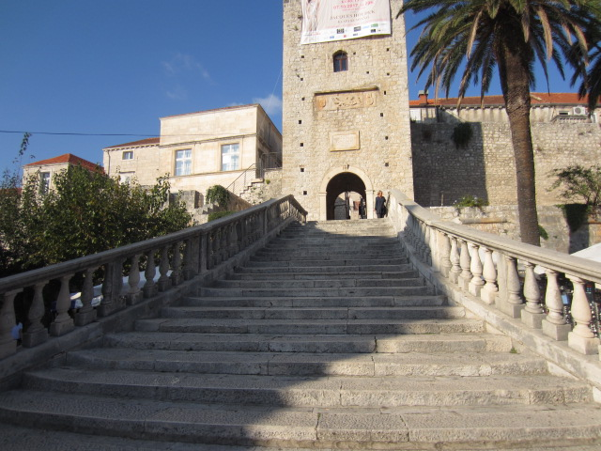
This is the main entrance to the old city. Over the doorway is the following detail.
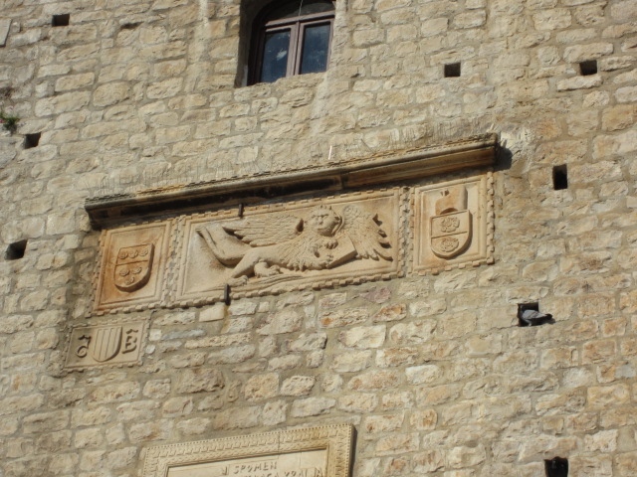
The winged lion has associations far back in history, starting in the fertile crescent. Later it was the symbol of St. Mark and is found in St. Mark’s Place in Venice, which played a major role in the island’s a long and complicated history, which has many similarities to Dubrovnik’s. In the 12th century Korčula was conquered by a Venetian nobleman and incorporated briefly into the Venetian Republic. Around this time, the local Korčula rulers began to exercise diplomacy and legislate a town charter to secure the independence of the island. Marco Polo’s birthplace is disputed as having been in Korčula or Venice.
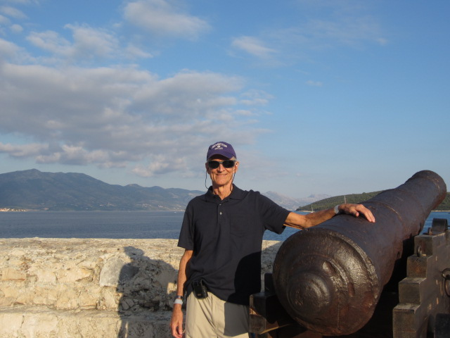
Tryg in old city with cannon facing the harbor
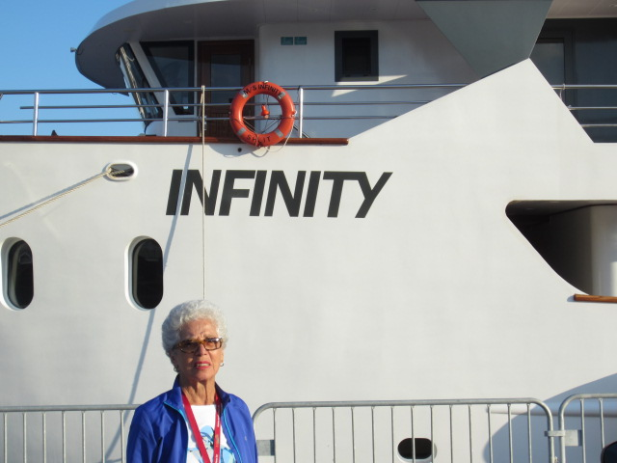
Sonia at the ship before departure for Vis
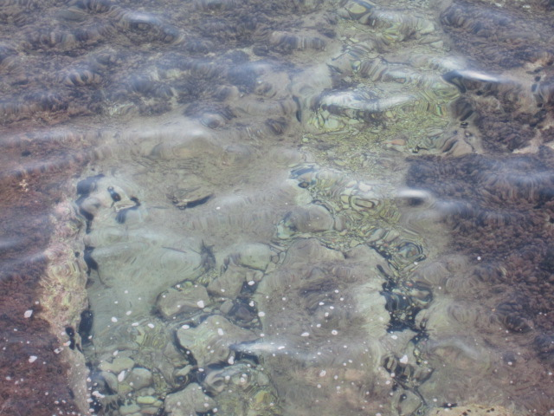
Shallow water demonstrates the Adriatic’s purity.
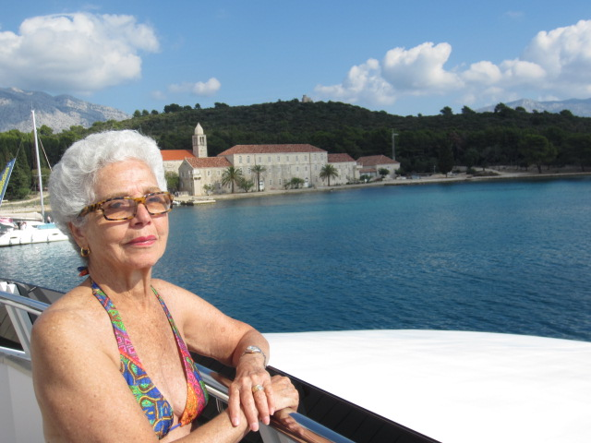
Sonia on board with Franciscan monastery in background
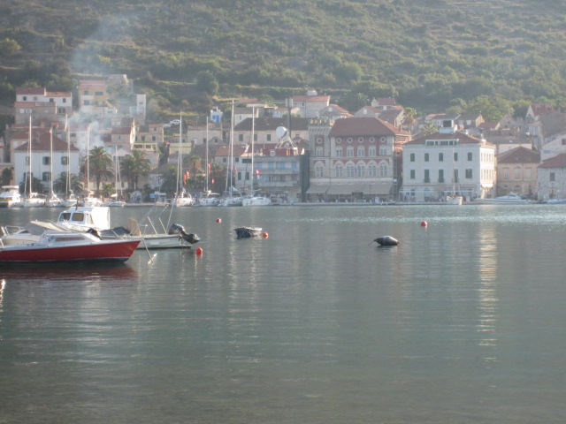
Vis is the outermost of the islands we visited. Like the others and some cities on the mainland, it has had a long and complicated history. One of the most interesting things we saw there was an ancient Roman bath. We were lucky to catch the archaeologists there to give us a tour.
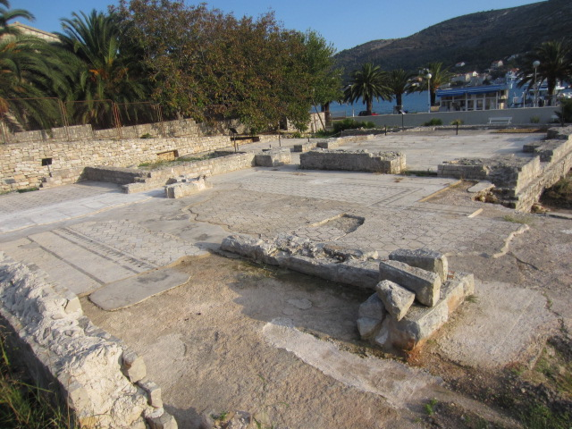
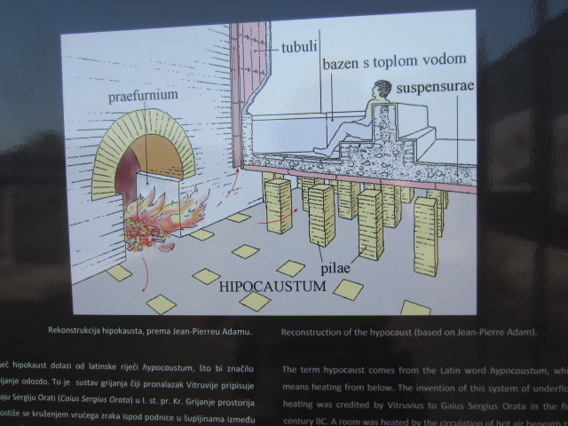
Here’s a of how the baths worked. Rather than tapping into naturally hot mineral water coming from below the ground, the ancient Romans heated the water underneath the baths.
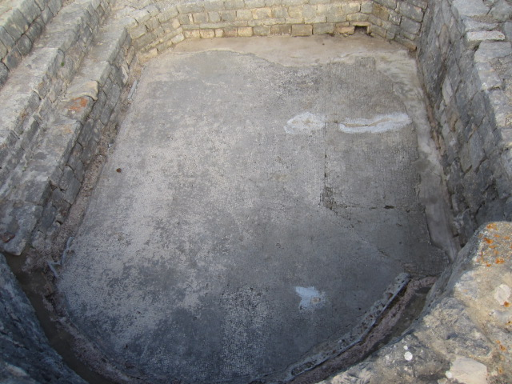
In this reconstructed bath, the ancient mosaic floor has been exposed.
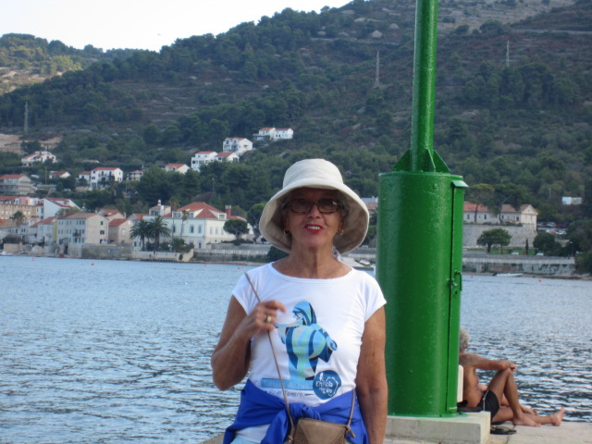
We liked Vis for its variety, it size and simplicity, and lack of development, especially tourism. It was a great place to stop!
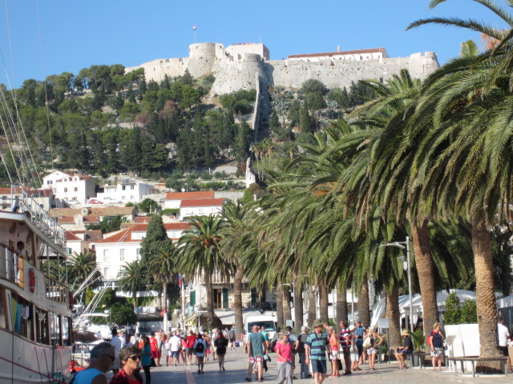
The last island where we spent a night was Hvar. Like most of the islands, it had fortifications that helped protect its population during the many attempted takeovers throughout Dalmatian history.
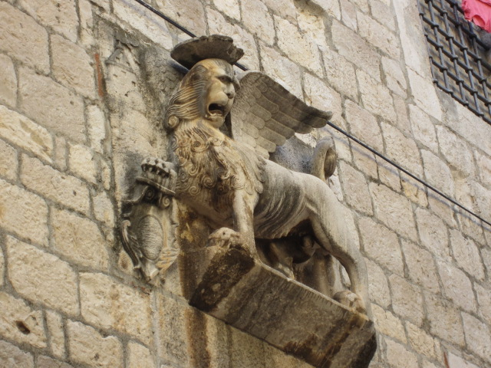
On our tour of the old city of Hvar, another winged lion turned up! Hvar also had various relations with regional power Venice during the Middle Ages. Here the lion of St. Mark looks angry about something.
Before leaving Hvar, we took boats small enough to enter the famous Blue Cave nearby. The cave was formed by the wave action of the sea, as sea water eroded the limestone rock which forms its walls.
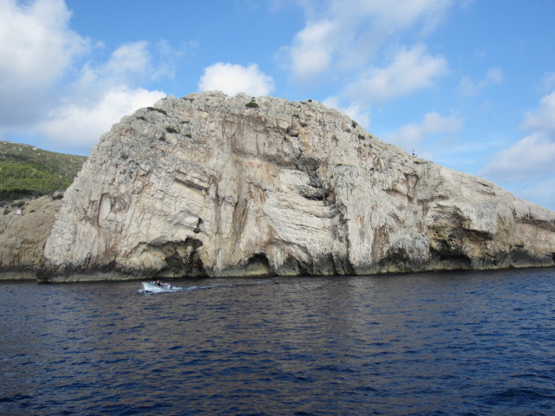
The cave opening is at photo center. The following shots show one of our boats arriving at the cave, the cave’s inside water color and illumination, and the view from the inside looking out.
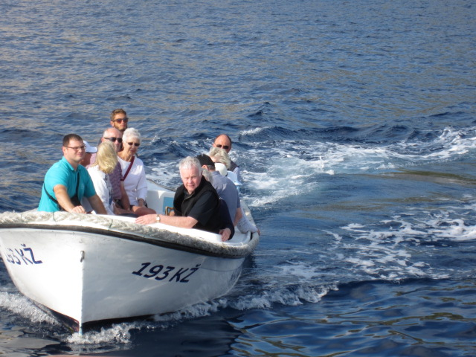
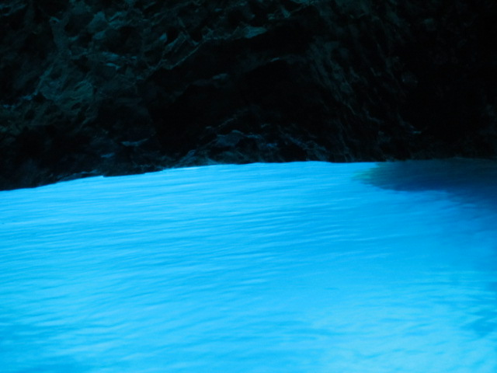
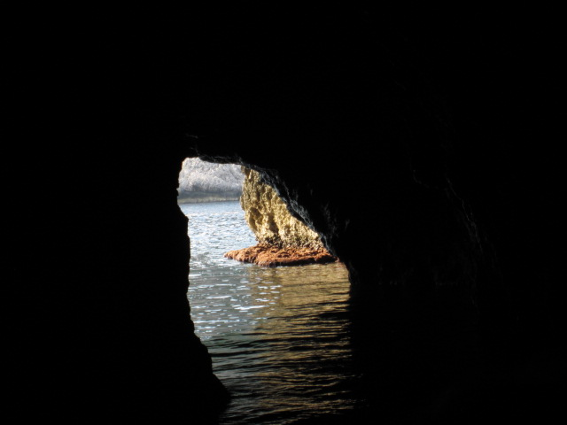

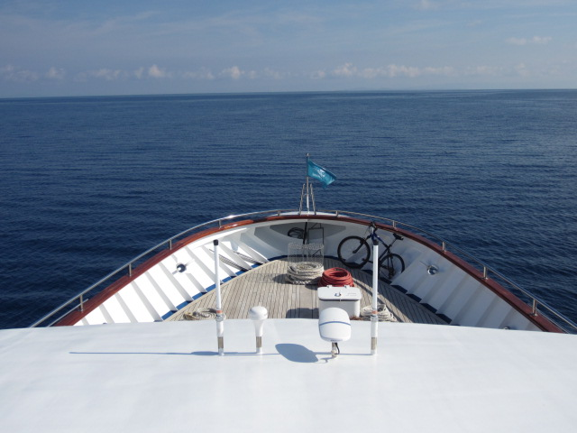
Our next stop was Brac, which we saw only from The deck of the Infinity.
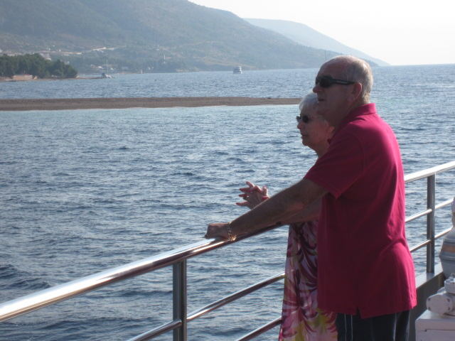
Here are our new friends Tony & Wendy from Yorkshire.
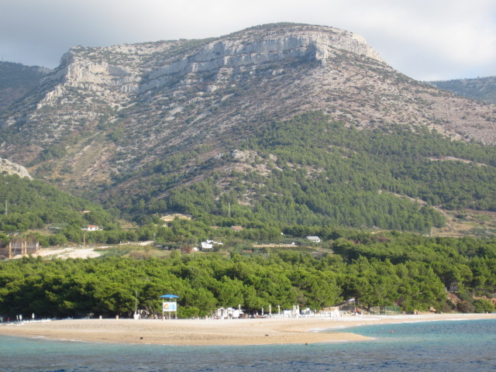
A view of Brac with one of its famous beaches in the foreground
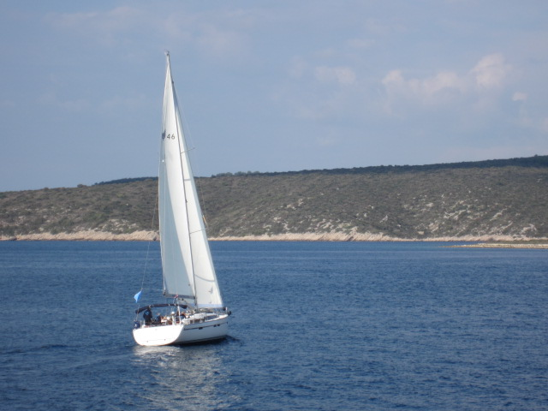
There were many small sailboats like this one in lots of places along the Adriatic Coast of Dalmatia. This was a particularly popular to sail between Hvar and Split, our destination for our last night aboard.
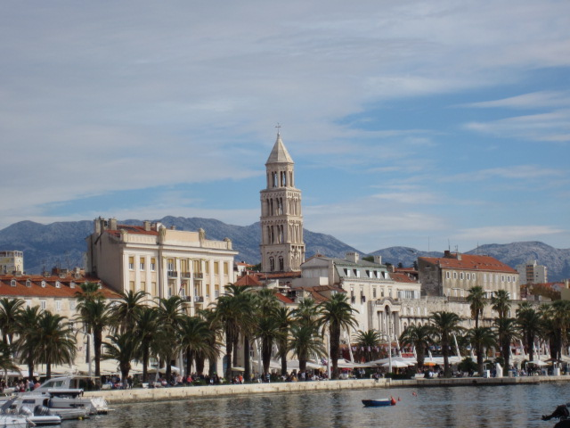
Split waterfront with tower inside the Roman Emperor Diocletian’s Palace built around 400 AD and now a declared a World Heritage Site. Called a "palace" because of its intended use as the retirement residence of Diocletian, the term can be misleading as the structure is massive and more resembles a large fortress.
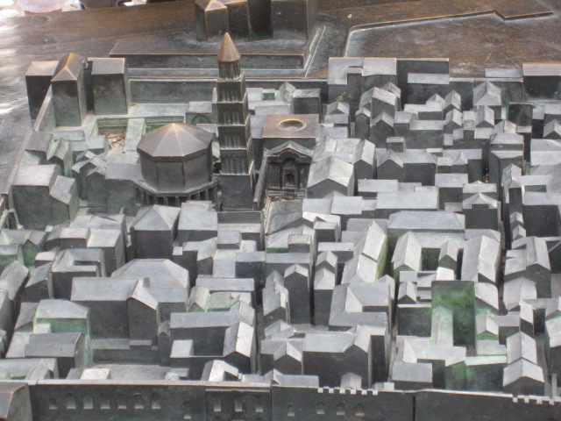
model of Diocletian’s Palace; buildings dedicated to the Roman gods in upper left corner
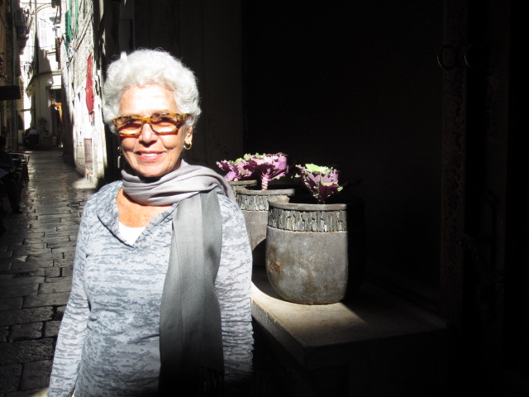
In the Middle Ages, a town formed within the fortified area around the Palace. Here is my muse on one of the alleyways within the protective walls.
. 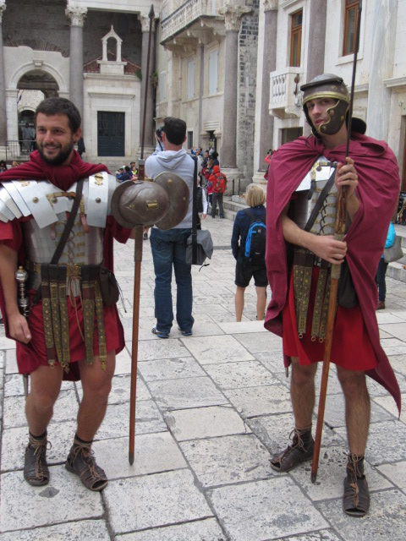
Living history as Roman Centurions within what is called the Peristyle of the Palace
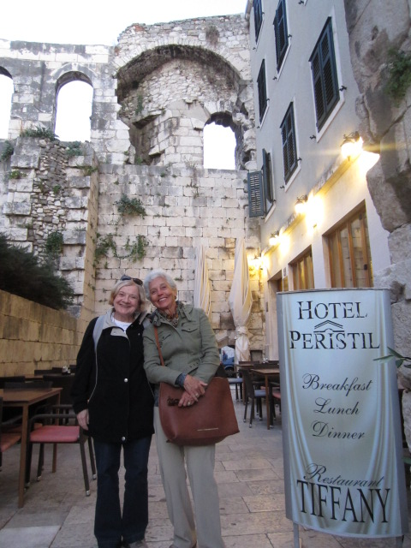
Posing with our Canadian friend Margaret outside our hotel with the Palace ruins. Note common wall of hotel on right with Roman wall in background. This was an archaeologist’s dream: to sleep within one of the old world’s best preserved Roman ruins!
During one of our days in Split, we took a day trip by bus to Trogir, which provides a good example of how serendipity can occur while travelling. We had never come across Trogir in our travel planning, but it was suggested to us by other travellers so we went and found it quite agreeable!
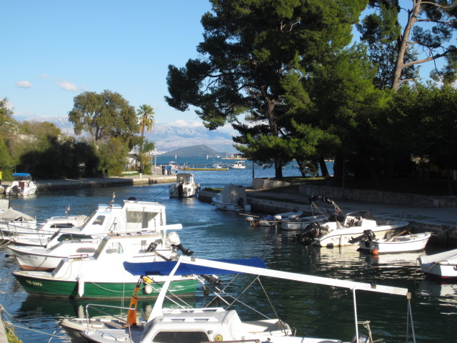
The historic town and harbor of Trogir has a population of about 13,000. Today it is part of the greater Split metropolitan area which numbers over 400,000 inhabitants. It is on the UNESCO World Heritage List as one of the best preserved medieval towns in Europe.

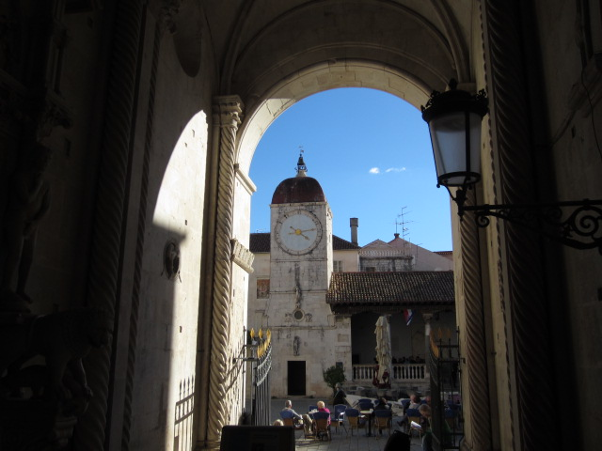
.
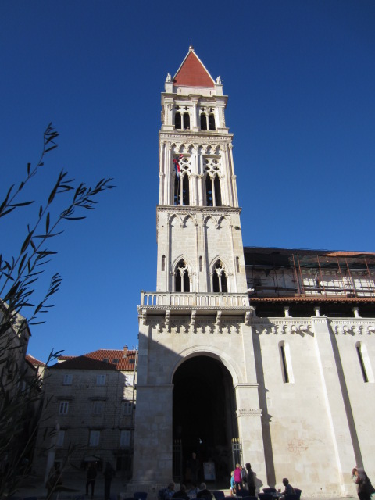
Here is the bell tower of the Cathedral of St. Lawrence in, built mainly in the Romanesque style in the 13th through the 17th centuries. Below is the cathedral’s west portal. The local architect and sculptor Master Radovan finished his work worked on it in 1240.
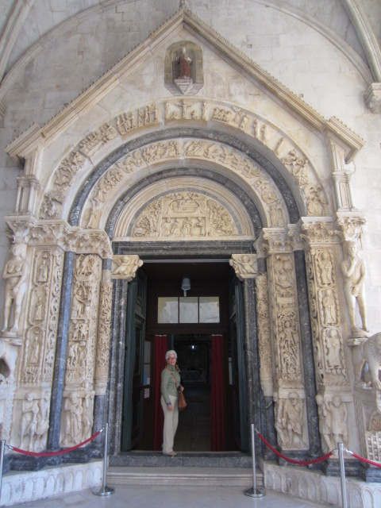
Before we left Split, we had this photo taken at the “secret” exit of Diocletian’s Palace just outside our hotel. It show what a great time we had there!
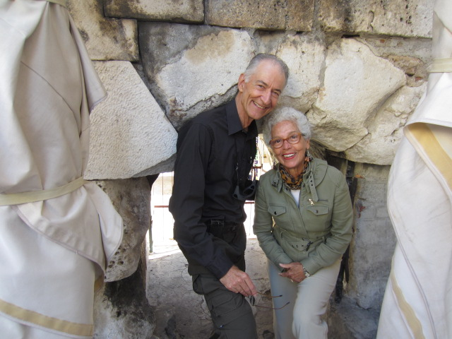
The final stop on the trip was Florence, still every bit as beautiful as when I first visited in 1962, but much more crowded. Our good friend Mário Pacheco provided a compelling reason for us to begin planning a trip when he invited us early in the year to attend the show announced in the next photo. Mario’s exhibit, “The Unperceived”, featured photos of pine bark he had taken in Rome’s Borghese Gardens. These “slices of nature” use the photographic framing and patterns in the bark to make the viewer take a closer look at nature.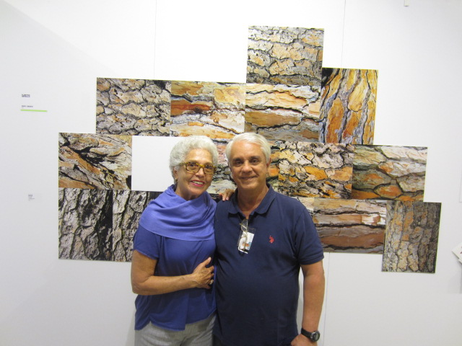

The exhibition was announced in this postcard: 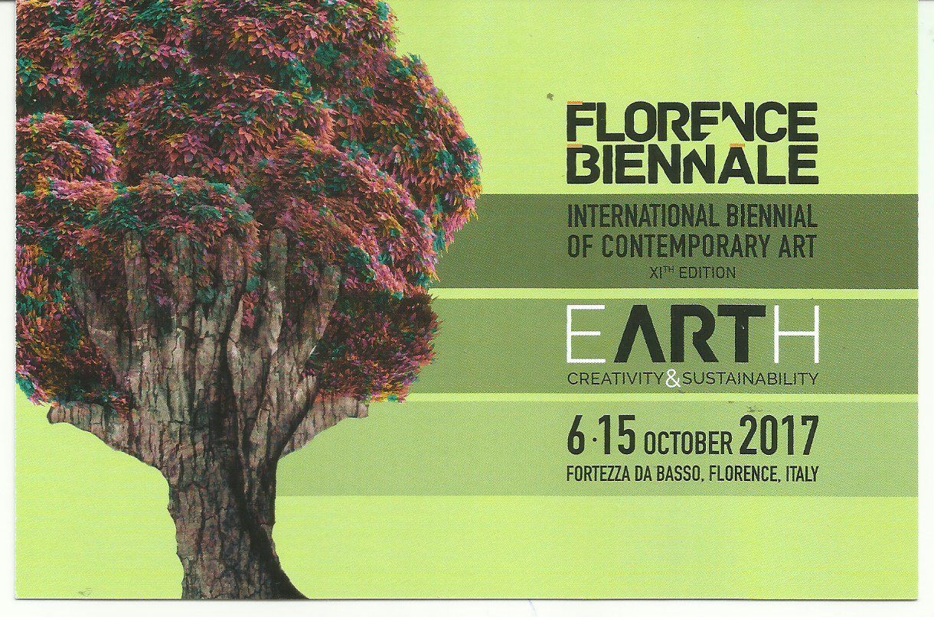
While Sonia spent some time with Mário and his wife Sandra, as well as Sandra’s brother Beto, and Sonia’s and my friends from Laguna Beach, Fernando and Arden, I had a chance to look at Renaissance art as well. I bought a Firenze card to use during three of the days we were there and managed to go through seven museums during that time! These included the Uffizi Gallery, Palazzo Vecchio, Bargello, Accademia, the Duomo, and Galileo Science Museum.
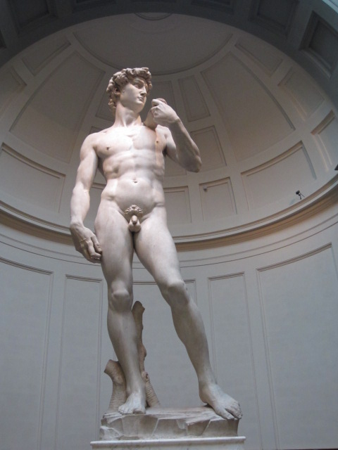
Michelangelo’s David, 1504
A number of Michelangelo's works of painting, sculpture, and architecture rank among the most famous in existence. In 1546 he became architect of St. Peter’s Basilica, Rome. Its dome, which has been called

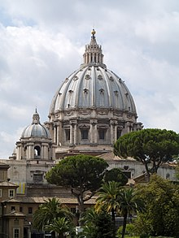
“the greatest creation of the Renaissance” was completed not long after Michelangelo’s death in 1564.
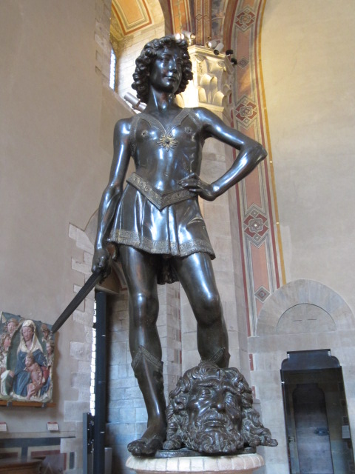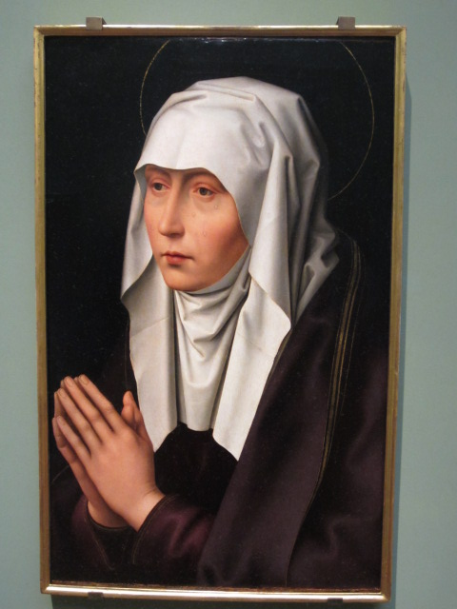
Donatello, David, 1457 Hans Memling, Mater Dolorosa, 1500 (copy)
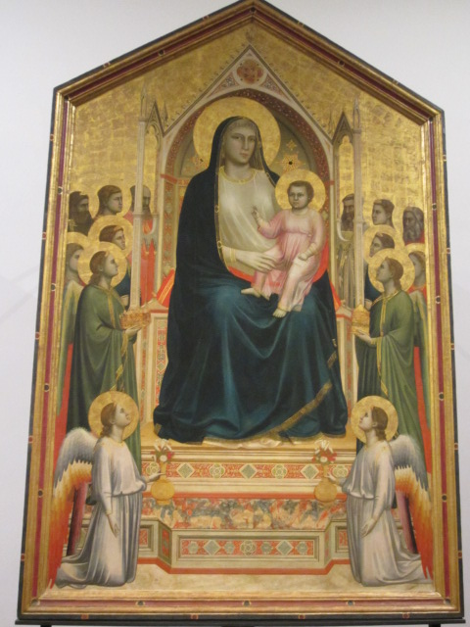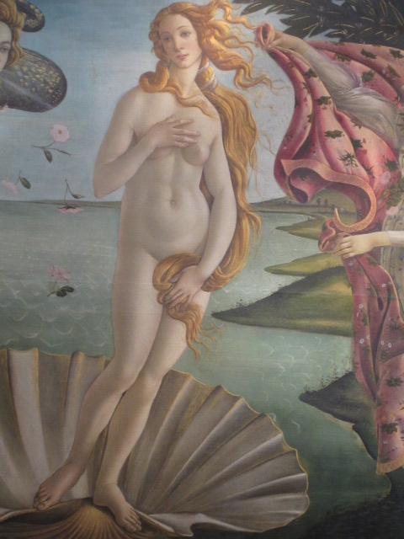
Giotto, Madonna Enthroned, ca.1310 Botticelli, Birth of Venus 1486 (detail)

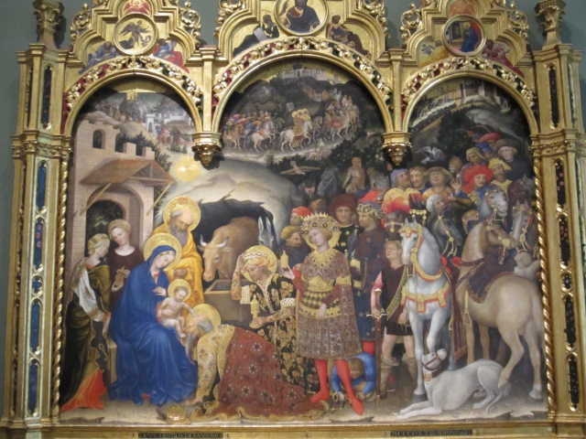
Adoration of the Magi, Botticelli, 1475
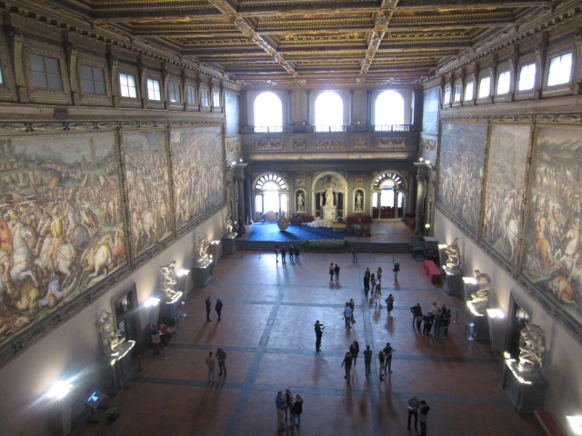
Palazzo Vecchio, Grand Hall
Overall, we had another very good year! We wish all of you happy holiday and a great 2018!

